WECC Generation Registration Request Form

# Registered Entity Information

Entity Name: Click or tap here to enter text. NCR ID#: Click or tap here to enter text.

# Type of Registration Request

New Registration  Yes  No Footprint Change[1]  Yes  No

Function(s): Click or tap here to enter text.

# Facility Information

**Asset Description Information**

Describe the generation asset(s) being registered or added to an existing registration.

Click or tap here to enter text.

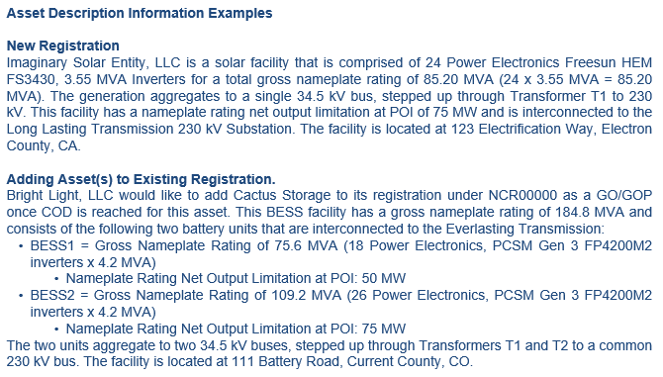

**Facility Information for New Registration or Footprint Change Addition**

|  |  |
| --- | --- |
| Facility Information | Description |
| **Interconnection Substation Name** |  |
| **Interconnection Voltage** |  |
| **Fuel Type** |  |
| **Inverter Manufacturer/Model** |  |
| **Inverter frequency support capability[2]** | Grid forming  Grid following |
| **Number of Inverters** |  |
| **Individual Inverter Rating (MVA)** |  |
| **Gross Nameplate Rating (MVA)** |  |
| **Nameplate Rating at POI (MW)** |  |
| **Initial Sync Date** |  |
| **Tentative/Effective COD:[3]** |  |

# Documentation Provided

**The following documentation is being submitted to WECC (check all that apply):**

[ERO Enterprise GO GOP Asset Verification Form](https://www.nerc.com/pa/comp/Registration%20and%20Certification%20DL/ERO%20Enterprise%20GO-GOP%20Asset%20Verification%20Form.xlsx)

* 4a Category 1 GO GOP Assets Tab
* 4b Category 2 GO GOP Assets Tab
* 5 Entity Change History Tab

Interconnection Agreement (submit all versions related to project)

Amended and Restated Interconnection Agreement(s)

Modification Request Report(s) | Material Modification Assessment(s)

Operating One-Line Diagrams (As Built)

* Depicting the Generation Resource(s) through to the Point of Interconnection w/Transmission Owner (TO) | Include collector system with individual feeders

Manufacturer’s Data Specifications – Solar/BESS Inverters | Wind Turbine Converters (if applicable)

Third-Party or Operating Agreement(s) (if applicable)

# Additional Information

Provided documentation should include accurate facility profile information (such as gross nameplate rating, capacity in-service agreement limitations, and inverter information). Explain if there are any discrepancies between documentation provided (such as Interconnection Agreement and One-Line Diagram information).

Click or tap here to enter text.

Will there be additional phases? Please describe.  Yes  No

Click or tap here to enter text.

Is the facility co-located with any other generation facilities, or are there any shared facilities? If yes, please provide a detailed explanation identifying the co-located or shared facilities and provide any relevant agreements.

Click or tap here to enter text.

# Attestation

The person listed below is the entity Compliance Contact or equivalent and affirms that they have

reviewed these responses and that the information provided is true and accurate to the best of their

knowledge.

Click or tap here to enter text.

**This form and supporting documentation should be submitted via CORES.**

**For questions about Registration, please contact:** [**registration@wecc.org**](mailto:registration@wecc.org)**.**

1. Adding or removing generation asset from a current NERC registration.
2. Grid forming inverters can create and regulate the grid voltage and frequency, while grid following inverters synchronize their output with the grid voltage and frequency.
3. The effective date for a new generation registration is effective based upon the commercial operation date (COD), which is defined on page 6 of the [ERO Enterprise Registration Procedure](https://www.nerc.com/pa/comp/RegistrationReferenceDocsDL/ERO%20Enterprise%20Registration%20Procedure.pdf).