WECC Generation Registration Request Form

Registered Entity Information

Entity Name: Click or tap here to enter text. NCR ID#: Click or tap here to enter text.

Type of Registration Request

New Registration ☐ Yes ☐ No Footprint Change ☐ Yes ☐ No
Function(s): Click or tap here to enter text.

Facility Information

Asset Description Information
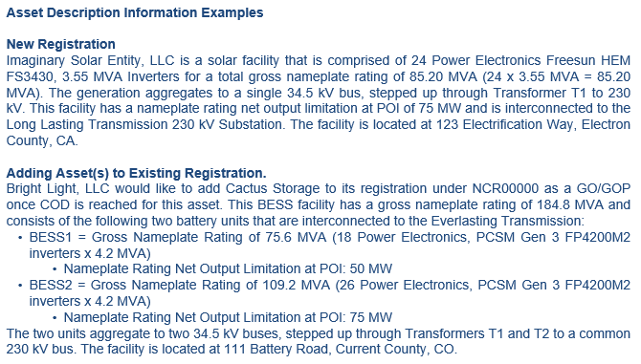

Describe the generation asset(s) being registered or added to an existing registration.

Click or tap here to enter text.
Facility Information for New Registration or Footprint Change Addition

Facility Information | Description
Interconnection Substation Name
Interconnection Voltage
Fuel Type
Inverter Manufacturer/Model
Inverter frequency support capability | ☐ Grid forming ☒ Grid following
Number of Inverters
Individual Inverter Rating (MVA)
Gross Nameplate Rating (MVA)
Nameplate Rating at POI (MW)
Initial Sync Date
Tentative/Effective COD:

Documentation Provided

The following documentation is being submitted to WECC (check all that apply):
☐ ERO Enterprise GO GOP Asset Verification Form
- 4a Category 1 GO GOP Assets Tab
- 4b Category 2 GO GOP Assets Tab
- 5 Entity Change History Tab

☐ Interconnection Agreement (submit all versions related to project)
☐ Amended and Restated Interconnection Agreement(s)
☐ Modification Request Report(s) | Material Modification Assessment(s)

☐ Operating One-Line Diagrams (As Built)
- Depicting the Generation Resource(s) through to the Point of Interconnection w/Transmission Owner (TO) | Include collector system with individual feeders

☐ Manufacturer’s Data Specifications – Solar/BESS Inverters | Wind Turbine Converters (if applicable)

☐ Third-Party or Operating Agreement(s) (if applicable)

Additional Information

Provided documentation should include accurate facility profile information (such as gross nameplate rating, capacity in-service agreement limitations, and inverter information). Explain if there are any discrepancies between documentation provided (such as Interconnection Agreement and One-Line Diagram information).

Click or tap here to enter text.

Will there be additional phases? Please describe. ☐ Yes ☐ No
Click or tap here to enter text.

Is the facility co-located with any other generation facilities, or are there any shared facilities? If yes, please provide a detailed explanation identifying the co-located or shared facilities and provide any relevant agreements.

Click or tap here to enter text.

CIP Inherent Risk Assessment – New Registrations Only

Please select the correct categorization regarding your entity’s external routable connectivity to non-NERC Registered Entities including vendors.

☐ High – Entity has external electronic communication to non-registered entities i.e., any other 3rd party.
☐ Medium – Entity has external electronic communication only to NERC Registered Entities.
☐ Low – Entity has external electronic communication within the Entity’s own registration.
☐ N/A – Entity has no external electronic communication.

For GOs only, please select the correct categorization regarding your entity’s capability to operate and monitor generation.

☐ High – Entity has monitoring and control capability of generation Cyber Assets, at a single location, with an aggregate impact greater than 3000 MW.
☐ Medium – Entity has monitoring and control capability of generation Cyber Assets, at a single location, with an aggregate impact between 1500 MW and 3000 MW.
☐ Low – Entity has monitoring and control capability of generation Cyber Assets, at a single location, with an aggregate impact less than 1500 MW.
☐ N/A – Entity has no monitoring and control capability of generation, only the GOP is responsible.

Does your entity have any Cyber Assets which are end-of-life?

Click or tap here to enter text.

Please provide any additional information if needed.

Click or tap here to enter text.

Attestation

The person listed below is the entity Compliance Contact or equivalent and affirms that they have
reviewed these responses and that the information provided is true and accurate to the best of their
knowledge.

Click or tap here to enter text.

This form and supporting documentation should be submitted via CORES.

For questions about Registration, please contact: registration@wecc.org.

Adding or removing generation asset from a current NERC registration.
Grid forming inverters can create and regulate the grid voltage and frequency, while grid following inverters synchronize their output with the grid voltage and frequency.
The effective date for a new generation registration is effective based upon the commercial operation date (COD), which is defined on page 6 of the ERO Enterprise Registration Procedure.

