WREGIS Stakeholder Advisory Committee
Meeting Agenda
Virtual
  - Link, Password: WECC
Dial-in Number: 1-415-655-0003
Attendee Access Code: 2633 748 9579
November 4, 2025
11:30 a.m. to 12:30 p.m. Mountain Time

Welcome, Call to Order—Chris Leyerle, Chair

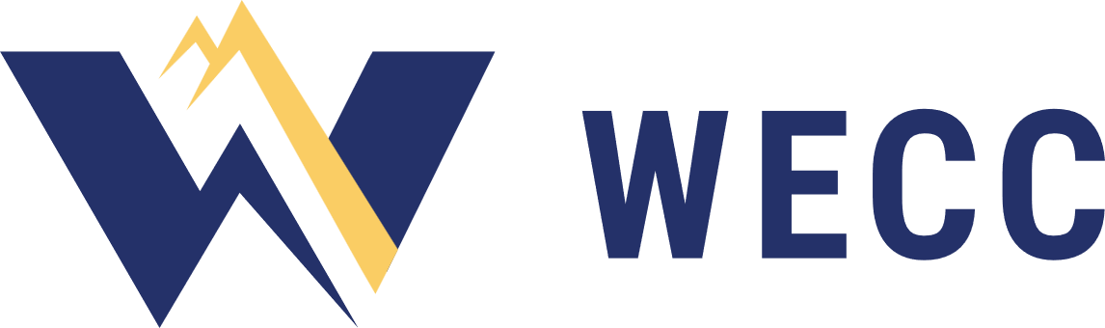
Review WECC Antitrust Policy—Andrea Coon
The WECC Antitrust Policy can be found on wecc.org.
Please contact WECC legal counsel if you have any questions.

Approve Agenda

Review and Approve Previous Meeting Minutes
Approval Item: Minutes of the meeting on November 4, 2025

CEC Retroactive Certificates Request—CEC Representative
AES Clean Energy / sPower LLC, Unit 18995
- WREGIS Operations and Status Updates—Andrea Coon
- WREGIS Software and Transition Updates—Jillian Lessner

Public Comment

Review New Action Items

Review Upcoming Meetings
December 2, 2025 Virtual
January 6, 2026 Virtual
February 3, 2026 Virtual

Adjourn

