Member Advisory Committee
Meeting Agenda
Salt Lake City, Utah
  - Link, Password: WECC
Dial-in Number: 1-415-655-0003
Attendee Access Code: 2870 413 3036
  - Register here to see the meeting link.
June 10, 2025
3:30 to 4:45 p.m. Mountain Time

Welcome, Call to Order—Brian Theaker

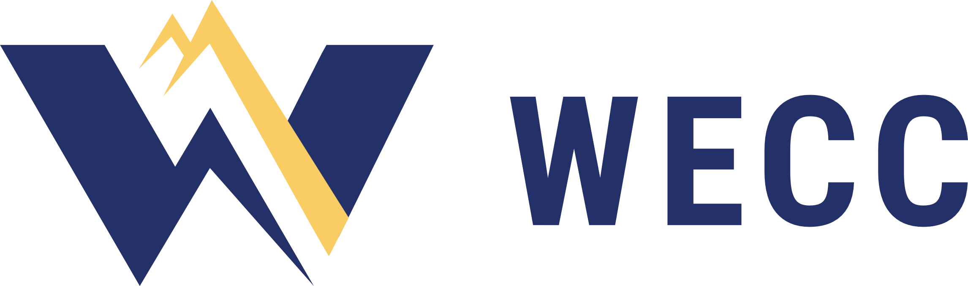
Review WECC Antitrust Policy—Brittany Huggins
The WECC Antitrust Policy can be found on wecc.org.
Please contact WECC legal counsel if you have any questions.

Approve Agenda

Review and Approve Previous Meeting Minutes
Approval Item: Minutes of the meeting on April 14, 2025

Review Previous Action Items—Brittany Huggins

Chair Remarks—Brian Theaker

Executive Remarks—Melanie Frye

Technical Session Discussion—Member Advisory Committee

Proposed Bylaws Revisions—Chris Parker

Work Group and Liaison Reports
Reliability and Assessment Committee—Fred Heutte
Reliability Risk Committee—Grace Anderson
Resource Adequacy Advisory Group—Brian Theaker

MAC Membership—Brian Theaker

Public Comment

Roundtable

Review New Action Items

Resources
State of the Interconnection
*Resources can be found on wecc.org

Review Upcoming Meetings
July 9, 2025 Virtual
September 18, 2025 Salt Lake City, Utah
November 5, 2025 Virtual

Adjourn

