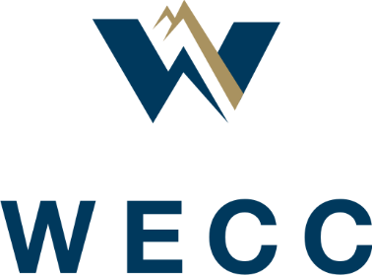

Section 4.9 Committee
Final Report and Recommendations
  - May 29, 2020

Section 4.9 of the WECC Bylaws requires the Board of Directors (Board) to conduct a governance and structure review. This review, commonly known as the “4.9 Review” is required every five years to assess:
whether WECC fulfill(s) its purposes in a manner that is consistent with its mission and vision…(and) consider whether the standards, obligations, processes and decisions WECC imposes on its Members are timely, fair, effective, and reasonable in view of the commercial, legal, regulatory, and economic needs and objectives of the affected Members. The assessment required by this Section 4.9 will be accompanied by recommendations for any changes the Board determines are warranted by the assessment.
On September 11, 2019, the Board created the Board Section 4.9 Review Committee (Committee) to conduct the 4.9 Review. The Committee was to be chaired by a Director and consist of another Director and representatives from the Member Advisory Committee (MAC), the Western Interconnection Regional Advisory Body (WIRAB) and Technical Standing Committees as well as the WECC CEO. The committee was charged to take direction from the Board throughout the review process and present a final report to the Board on June 17, 2020.
The Committee consists of:
- Ric Campbell, Chair, WECC Director
- Melanie Frye, WECC CEO
- Maury Galbraith, representing WIRAB
- Rich Hydzik, representing Technical Standing Committees
- Brian Theaker, representing the MAC
- Richard Woodward, WECC Director

Background
The previous 4.9 Review was completed in December 2015 after a year-long process. The report produced was comprehensive, reflecting a thorough review of the organization following the transition from a stakeholder-based trade organization to an independent organization focused on social welfare.
In preparing for the current iteration of the 4.9 Review, the Governance Committee (GC) solicited comments from the MAC, WIRAB, WECC membership, WECC management, and Directors on what this review should look like. Based on this feedback from stakeholders, the GC recommended a plan for a 4.9 Review focused on a limited set of issues with analysis performed by specialized work groups in an open and transparent process.
The Board agreed with the GC recommendations and in open session discussed the issues list developed by the GC and stakeholders. The Board created the Committee as described above and selected two issues for review:
- WECC’s stakeholder engagement model, and
- the effectiveness of WECC’s strategic planning process.
On December 4, 2019, the Committee made its first report to the Board and the Board approved issue statements that formed the scope of work. The Committee formed two work groups to undertake a detailed assessment of each of the issue statements. These two work groups were organized in December of 2019 and began their work in January 2020.

The Work Groups
The Stakeholder Engagement Work Group (SEWG) and the Strategic Planning Process Work Group (SPWG) were formed by the Committee and tasked with developing recommendations based on the approved issue statements. Each work group had a set of study questions.

SEWG
Members of the SEWG were selected to provide the necessary stakeholder perspectives. The work group consists of:
- Margaret Albright, Operating Committee
- Dave Angell, Reliability Assessment Committee
- Eric Baran, WIRAB
- Ric Campbell, WECC Director
- Robert Follini, Market Interface Committee
- Steve Goodwill, Chair, WECC Management
- Linda Jacobson-Quinn, MAC
The SEWG’s study questions were:
- Could WECC and member companies operate more efficiently and effectively if the structure of current committees were replaced by a task force model with subject matter experts engaged on specific tasks rather than being members of a standing committee?
- Are there other models that may enable WECC to optimize stakeholder engagement?
- What lessons have we learned from the creation of the RAC?
- How well does the current structure address emerging risks and threats to reliability?
- Is the current structure nimble enough to address immediate concerns as they arise? Should the sheer number of committees, subcommittees, and task forces be evaluated for the possibility of elimination or consolidation?
The SEWG met every other week, with one in-person kick-off meeting in Salt Lake City.

SPWG
Each member of the SPWG has strategic planning experience and knowledge. The work group consists of:
- Duncan Brown, MAC
- Jillian Lessner, Chair, WECC Management
- Lisa Milanes, California ISO
- Jennifer Rodgers, Western Area Power Administration
- Holly Taylor, WIRAB
- Richard Woodward, WECC Director
The SPWG’s study questions were:
- The electric industry continues to experience a rapidly changing environment. The level of variable generation in the resource mix and the increased use of digital control technologies present new risks to the reliability and security of the electric grid. Additional risks and threats will undoubtedly continue to emerge. With the ERO Enterprise revising its long-term strategy, how will these changes impact WECC?
- How can WECC improve and streamline its strategic planning process?
- How can WECC continue to align with the ERO Enterprise Long-Term Strategy while reflecting the uniqueness of the West?
- What are the long-term focus areas?
- How does WECC ensure member and stakeholder involvement in the strategic planning process?
- Is the biennial Western Reliability Summit a useful method to gather input for the strategic plan?
- How long should the strategic planning horizon be?
The SPWG met weekly, with one in-person kick-off meeting in Salt Lake City.
Both the SEWG and the SPWG presented their preliminary reports to the Committee on March 10, 2020. The SEWG report was in the form of a draft written report. The SPWG report was in the form of an oral report and slide deck.
Each work group was asked questions and given additional feedback. The SEWG’s final recommendation report was produced at a meeting on April 3, 2020. The SPWG’s final recommendation report was produced at a meeting on March 27, 2020.

Review of Work Group Reports
The Section 4.9 Committee has reviewed and accepted the reports of the SEWG and the SPWG and is including them as attachments to this report.

SEWG Report
The SEWG approached the study questions about stakeholder engagement with a goal of inventing a new future rather than improving on the past. In the process, they arrived at a vision of stakeholder engagement at WECC as the “Home for Reliability and Security in the Western Interconnection.”
The SEWG conducted a detailed analysis of the current organizational structure, the work produced in various stakeholder groups, and lessons coming out of the formation and experience of the Reliability Assessment Committee. These analyses led to the creation of guideposts for future stakeholder engagement, communication and outreach, and organizational design.
The Section 4.9 Committee agrees with these guideposts and the recommendations they produce with the following notes:
- The SEWG report does not address engagement at meetings of the board of directors or at the Annual Meeting of the Members.
- The report focuses on the contribution of the technical committees and doesn’t mention other stakeholder groups such as the Member Advisory Committee and does not explicitly call out WECC outreach to policy makers.
- The report leaves open the timeline for completion of a stakeholder engagement initiative and the composition and governance of a task force to lead this initiative.
These notes are addressed in the recommendation section below. See Appendix A for a copy of the full SEWG report.

SPWG Report
Like the SEWG, the SPWG approached its task with a future focus and the desire to create the best planning process rather than improve on the current one.
The SPWG analyzed the current strategic planning processes, terminology, and timelines to identify parts of those processes that are and are not working and to understand why they were or were not valuable to WECC. The work group then identified alternative solutions that would be better suited to WECC and more likely to produce the desired outcomes in the Board-approved issue statements.
The Section 4.9 Committee agrees with the SPWG analysis and recommendations. The recommendations for the SPWG are spread across several pages in the work group report and are consolidated in the recommendations section below. See Appendix B for a copy of the full SPWG report.

Communication and Outreach
Both work groups identified communication and outreach as key activities. The Committee notes that this important activity is under the direction of WECC management and must be a focus of WECC efforts in implementing the following recommendations.

Recommendations
The Section 4.9 Committee makes the following recommendations to the WECC Board of Directors.
Stakeholder Engagement
WECC is uniquely positioned to serve its members as the Home for Reliability and Security in the Western Interconnection. Members benefit from accessing and contributing to the experience and knowledge of other members and WECC staff.
Create a Stakeholder Engagement task force to:
- Develop potential structures for the organization that will improve the stakeholder engagement model given the guideposts created by the SEWG. This effort should be completed within 6 months.
- Present these structures for member feedback.
- Consider how WECC SMEs should engage stakeholders to improve WECC’s ownership in work products.
- Consider whether stakeholder groups should either disband or go on hiatus if no current analysis or work product is needed.
- Develop metrics to track whether implemented changes are improving stakeholder engagement. We suggest those metrics should include and go beyond tracking attendance in committee meetings.
While the issue statement provided to the SEWG seemed to limit the stakeholder engagement analysis to the Technical Committees, the Committee recommends the task force consider stakeholder engagement more broadly, to include MAC and policy makers, as well as participation at Board meetings and the Annual Meeting.
Strategic Planning Process
- Develop a long-term strategy with a five- to seven-year horizon anchored to WECC’s Vision and Mission Statements. Use a linear representation of the processes to increase usefulness to stakeholders and draft a document that outlines the long-term strategy and reliability risk priorities development processes in detail. Adopt more traditional and widely understood terminology.
- Ensure stakeholder engagement in the development of WECC’s Long-Term Strategy and Reliability Risk Priorities. Develop a Communications and Outreach plan for the Long-Term Strategy and WECC’s Reliability Risk Priorities. Increase engagement and understanding of the long-term strategy through two-way communication, including an interactive forum at the Annual Meeting.
- Improve the development process for WECC’s Reliability Risk Priorities through a formal Communications and Outreach plan and by working with MAC leadership to increase MAC’s engagement in the Reliability Risk Priorities Workshop.
- Eliminate the Western Reliability Summit.
- Eliminate the three-year operating plan. Review the development processes for work plans and the Business Plan and Budget to ensure no critical information is lost without the three-year operating plan.

The Committee recommends that Management report back on the status of each of these recommendations at subsequent Board Meetings.

Stakeholder Engagement Work Group (SEWG)
Report to the Section 4.9 Review Committee
  - Steve Goodwill, SEWG Chair
  - April 3, 2020

Strategic Purpose
The SEWG was created by the Section 4.9 Review Committee to take a focused look at the process for engaging members and other stakeholders in the collaborative work of WECC and to address the following questions:
- Could WECC and member companies operate more efficiently and effectively if the standing structure of current committees was replaced by a task force model with subject matter experts (SME) engaged on specific tasks rather than being members of a standing committee?
- Are there other models that may enable WECC to optimize stakeholder engagement? What lessons have we learned from the creation of the Reliability Assessment Committee (RAC)?
- How well does the current structure address emerging risks and threats to reliability?
- Is the current structure nimble enough to address immediate concerns as they arise?
- Should the sheer number of committees, subcommittees, and task forces be evaluated for the possibility of elimination or consolidation?

Background
Before 2007, WECC’s roles and responsibilities were determined by the industry through a stakeholder board of directors to meet the needs of the members. WECC was organized to bring utilities together to develop and then adhere to agreed guidelines and best practices through an inclusive and rigidly defined technical committee structure, which was intended to promote common practices while protecting individual entity interests. Since 2007, WECC has evolved as an independent Regional Entity operating under a NERC delegation agreement with statutory authority from FERC in the United States.
Today, many WECC stakeholders believe WECC should use its unique interconnection-wide perspective and capabilities to identify, assess, and report on emerging reliability and security issues to inform industry, policymakers, and regulators across the West. This is an additional role to the one WECC performed throughout most of its six-decade history. To accomplish this, WECC must effectively and efficiently use the knowledge and experience of its stakeholders. It is crucial that we ask ourselves, “How can we best engage our stakeholders to support the analysis and outreach expected of WECC, now and in the future?”

Work Group Approach and Work Group Vision
Our work is guided by the Board-approved Issue Statement quoted above and attached as an appendix to this report. Throughout, we have focused on the “Desired Outcomes,” which require us to ask, “What do we want our stakeholder engagement to achieve?” rather than “Here is what we currently have; how can we make it better?” This emphasis on “inventing the future,” rather than merely “tweaking the past,” has allowed us to identify new possibilities not tied to past structure and process.
Early in our discussions, we focused on development of guiding principles and a vision to which WECC’s stakeholder engagement model can adhere. At its core, we determined stakeholder engagement must:
- Ensure stakeholder experience, knowledge, and expertise are available in a timely, efficient, and cost-effective way to help deliver on WECC’s reliability and security mission;
- Foster collaboration, cooperation, and a common commitment to reliability and security;
- Engage stakeholders as partners; and
- Provide a “safe space” for discussing issues and education.
From these principles, we developed a simple vision to guide our deliberations and recommendations, and to frame all stakeholder engagement at WECC:
WECC is the “Home for Reliability and Security in the Western Interconnection.”
WECC has existed as an organization and as a forum for over 50 years. WECC’s longevity and consistency form the basis for much of the value stakeholders find in WECC.
WECC has been called the Western Interconnection’s “Home for Reliability.” That phrase reflects that WECC has value as a place where experienced SMEs can work together and connect in a safe, known, and consistent space to produce timely and relevant solutions to threats to the reliability of the bulk power system.

Analysis—Organizational Structure
The work group began by reviewing the current organizational structure for stakeholder engagement with WECC—the technical committees and their associated subgroups. The analysis performed by staff and presented to the work group is contained in Appendix A and Appendix D of this report. While the present should not necessarily guide the future, this review led to a few conclusions worth keeping in mind as we think about the future:
- Based on recent attendance data, with few exceptions, member attendance at technical committee and subgroup meetings has been relatively stable since 2018. It is worth noting that members continued to engage at WECC even as they were working on urgent matters like changing their Reliability Coordinator (RC).
- The Standing Committees have three-year work plans to address WECC’s Near-Term Priorities and are making progress on those products. However, most technical committee subgroups are not focused on activities addressing WECC’s near-term priorities.
- Most subgroups have not finalized work products nor created items for approval by parent groups in the last two years.
- Many subgroups are performing valuable work delivering on WECC’s responsibilities and benefit from a stable structure in which to accomplish their work.
The example provided by the RAC is also instructive. The RAC was deliberately and thoughtfully created following the prior section 4.9 review “to provide coordinated reliability assessments of the Western Interconnection Bulk Electric System (BES) over the planning horizon and to provide related advice and recommendations to the WECC CEO and Board of Directors (Board).” However, the RAC’s own recent survey of its effectiveness revealed that, four years into its existence, it remains unclear whether the RAC structure is more efficient than the prior structure; there are challenges in keeping stakeholders engaged; and governance requirements have created challenges in running successful meetings and making decisions. In response, the RAC has proposed various governance and structural changes, but has not sought fundamental change.
Based on this review, the work group decided a first step in its work should be to create “guideposts”—a conceptual framework describing the desired attributes of WECC’s future stakeholder engagement model. The work group started with the “Desired Outcomes” taken directly from the Stakeholder Engagement Issue Statement drafted by the Section 4.9 Review Committee:
- There is a rekindled excitement about engaging with WECC and joining with colleagues to address critical reliability issues.
- This new excitement comes from a clear line-of-sight from the work being carried out for the reliability and security of the interconnection.
- The work is compelling, focused, relevant, and useful because it serves the public interest and represents what is best for reliability and security within the interconnection.
- The model uses the talent within the industry to apply the right expertise to solve each issue.
- The model is adaptable and multi-disciplined, which allows for quick development of complete solutions and recommendations.
- The model addresses the delegated responsibilities in the NERC-WECC Delegation Agreement.
The work group members then identified several attributes that WECC and its stakeholder engagement must possess to achieve these outcomes:
- Overarching Themes—
  - WECC’s stakeholder engagement model must ensure stakeholders see WECC as the “Home for Reliability and Security in the Western Interconnection.”
  - WECC must be a place where stakeholders feel like partners—a safe, intellectually stimulating place to discuss and debate, and a place that provides opportunities for education and influence.
  - Stakeholders support WECC’s mission, strategic direction, and Near-Term Priorities set by the Board.
  - Structure, process, and activities should be enhanced to provide the greatest value while considering cost to WECC and its members. They should be adaptable and responsive to changing risks to the BPS.
- Harnessing expertise and experience—
  - WECC and stakeholders support prompt and thorough analysis of issues of reliability and security in the Western Interconnection.
  - WECC stakeholder engagement must motivate and enable stakeholders to add value to WECC’s work in a timely and efficient manner.
  - Work will give value to stakeholders in the form of education and promote reliability and security in the Western Interconnection.
  - Stakeholder groups are partners that provide expertise to enhance WECC’s mission.
  - Stakeholder entities get value from participating and from outcomes.
- WECC:
  - Focuses its efforts and those of stakeholders on issues proportionate to reliability and security risks existing in the Western Interconnection.
  - Performs its work in a timely and transparent way.
  - Actively seeks out member viewpoints and provides prompt responses to member feedback.
  - Owns the work product.
  - Does work that can be used in multiple ways, increasing efficiency and effectiveness.
  - Ensures work products do not duplicate other industry and stakeholder efforts.
  - Educates stakeholders on WECC work products.

Analysis—Communications and Outreach Considerations
Successful stakeholder engagement requires effective communication and outreach. The work group recognizes that WECC management is responsible for communication and outreach. However, a full analysis of stakeholder engagement demands an exploration and identification of the ways communication and outreach can help create and support engagement. The work group received and considered information from staff about WECC’s communications and outreach programs and activities. The work group also looked at lessons from WECC’s compliance engagement activities. Appendix B of this report contains staff information on communications and outreach programs and activities. Appendix C contains information on compliance-specific engagement.
Following this review, the work group established a set of “guideposts” to help management develop communication structures that allow for stronger connections between WECC and its stakeholders. These guideposts, and any recommendations coming from them, will inform management’s planning and implementation to enhance stakeholder engagement. The guideposts are—
Efficient and effective channels of communication exist between—
- WECC’s technical committees and work products, and the people and organizations that benefit the most from this knowledge (e.g., policymakers).
  - The people working on specific reliability challenges can share ideas and efforts with others who are also working on those challenges.
- WECC and industry executives.
  - Industry executives are aware of WECC’s Near-Term Priorities. Industry executives are aware that volunteer labor from their organization contributes to the solution of reliability challenges.
- WECC liaisons and the volunteers who work on WECC technical committees.
  - WECC can effectively communicate with industry experts working on reliability challenges.
- Stakeholders and WECC.
  - Stakeholders can effectively communicate with WECC about reliability challenges.

Analysis—The Business Case for Stakeholders to Participate
The member representatives on the SEWG considered the business case to be made for stakeholder participation in WECC and arrived at the following:
WECC is uniquely positioned to serve its members as the Home for Reliability and Security in the Western Interconnection. Members benefit from using the experience and knowledge of other members and WECC staff. Because of the collaborative nature of the work, the knowledge of WECC staff, and the trust WECC has built among members, best practices are shared, as are lessons learned. As a voice for the Western Interconnect, WECC provides members with a way to strengthen and align their advocacy on issues of importance to the West.
Each member class has its own value experience, in addition to the global value provided by WECC.

Class 1 and 2: Large and Small Transmission Owners
- In an interconnected electrical system, the reliability of each member’s system is affected by the reliability of the other members’ systems and the whole system. The NERC Reliability Standards set forth a national set of minimum requirements to maintain reliable electric service. WECC provides an ability to tailor reliability standards to the Western Interconnection operations regarding contingency reserve, time error correction, maintenance, unscheduled flow relief, remedial action schemes monitoring, and power system stabilizer operation.
- WECC provides a pool of SMEs to analyze events and future load, resource, and power transfer scenarios throughout the Western Interconnection.
- Coordinated Western Interconnection power flow, dynamics, production cost, short circuit, and environmental models for use in analysis.
- SMEs participate in subcommittees that are focused on their technical area and build a network of knowledge and support that benefits advancements and growth for the SMEs themselves, the technical field of knowledge, and the reliability of the Western Interconnect

Class 3: Transmission Dependent Energy Service Providers
- Class 3 members rely on a reliable and efficiently-operated interconnected system to conduct their business, whether that business is providing physical energy and capacity, economically bringing together energy buyers and sellers to their mutual advantage, or providing consulting and analysis services to clients. Class 3 members rely on WECC to promote reliable and efficient operating practices, to exchange best practices, and to stay abreast of issues that affect their commercial success.
- Class 3 members also depend on WECC’s experience, visibility and analysis to identify emerging reliability issues and inform policy makers as to how these issues affect the reliability of bulk electric supply and, therefore, Class 3 member business interests.

Class 4: End Users
WECC provides forums such as the MAC and RAC, for utility consumer advocates and non-profit advocacy organizations to provide input into key reliability and planning issues on behalf of end use customers of the electric system for whom the system is built to serve. Participation in the WECC committees and subcommittees also provides a means for advocates to be informed regarding system resource adequacy and operations.

Class 5: Representatives of State and Provincial Governments
WECC provides a forum for government representatives to engage with the industry on present system operations and capabilities along with the ability to advocate for reliability. Also, through future scenario analysis, the members may better understand the impacts of policy decisions.

Back to the Beginning: Did the Work Group Answer the Committee’s Questions?
As noted under the Strategic Purpose section above, the Section 4.9 Review Committee asked the SEWG to answer five fundamental questions. Before discussing the SEWG’s recommendations, it is instructive to consider whether the SEWG has answered each of these questions and, if not, why not.
- Could WECC and member companies operate more efficiently and effectively if the standing structure of committees was replaced by a task force model with SMEs engaged on specific tasks rather than being members of a standing committee?
The SEWG has not decided whether WECC and member companies could operate more efficiently if the current structure was replaced by a task force model. This question calls for a yes or no answer, but, having reviewed the activities of the current committee structure, the SEWG believes that this inquiry should distinguish between the on-going responsibilities and activities of WECC and those emerging issues whose analysis and resolution may require a unique or “one-off” organization to address. The SEWG believes the ongoing responsibilities function well in a stable structure.
The SEWG suggests a Stakeholder Engagement Task Force (SETF) be created to work with a broader range of members and WECC staff to offer alternative committee, task force, user group, and forum structures that can address the unique and “one-off” challenges that need broad perspectives that the current organizational structure of WECC may lack.
- Are there other models that may enable WECC to boost stakeholder engagement? What lessons have we learned from the creation of the RAC?
Although the SEWG did not address the question of other models in detail, the group recognizes that the current Standing Committees provide a potential pool of SMEs who could contribute to the work of a task force or other model for stakeholder engagement. The Standing Committees also act as a venue for member collaboration.
One model to further explore is one that would give members a forum to discuss common topics, which could allow those members to form ad hoc groups to accomplish a specific task within a defined timeframe.
The lessons learned from creating the RAC include:
- An overly prescriptive governance structure resulted in an inability for subcommittees to achieve quorum, which delayed action;
- Distinctly different SMEs will disengage when combined into a single subcommittee;
- the elimination of a WECC-based, multi-vendor software user group resulted in the loss of vendor influence for software enhancements focused on the Western Interconnection; and
- Even though there was a MAC-RAC representative, more MAC engagement is needed to gain greater acceptance of study results.
- How well does the current structure address emerging risks and threats to reliability? Is the current structure flexible enough to address immediate concerns as they arise?
Although the Committee posed these as two separate questions, they are closely related, and together they pose the basic question: Is the WECC committee structure able to quickly address emerging reliability risks and concerns? WECC can form task forces in the current structure. The JGC is starting to do this with cross-committee issues. In considering this question, the SEWG noted that a risk or concern may be unique to cybersecurity, or the Operations or Planning timeframe. Conversely, it may bridge all of these. The goal of the JGC is to look at emerging issues with a broad view and use the joint Standing Committee meetings as a forum to discuss those items. The individual committees also discuss the risks from their specific perspectives, but more can be done to create greater coordination among the SMEs.
- Should the sheer number of committees, subcommittees, and task forces be evaluated for the possibility of elimination or consolidation?
The SEWG has discussed the elimination or consolidation of the current committees. The SEWG feels more research is needed on the purpose, activities, and work-product of the individual committees, which will be part of the work of the task force.

Recommendations
Although much of the SEWG’s work has been about scoping the problem and developing a set of guideposts on how to think about stakeholder engagement at WECC, more work needs to be done to apply those guideposts to the current stakeholder engagement model.
The SEWG takes the “Stakeholder Engagement” in its title seriously. We also take caution from the RAC experience with a change to their structure not resulting in the envisioned engagement, efficiency, and effectiveness. The SEWG comprises a reasonable cross-section of representatives of various stakeholder groups. Nonetheless, we recognize that we are a small group that cannot represent the views of all stakeholders. We also recognize that great ideas about stakeholder engagement likely exist in the broader stakeholder community. Finally, we are aware it is difficult for a small group such as we are to analyze and make recommendations on behalf of a stakeholder community literally numbering in the thousands. Additionally, WECC staff plays an important role in the committees and the work of the organization. Therefore, WECC staff (committee liaisons, technical experts, and management) should be included in the structural review.
Answering the questions posed by the 4.9 Review Committee about stakeholder engagement requires, primarily, the engagement of many stakeholders. While the SEWG has done its best over two months to analyze the issues and think about possible alternatives, any consideration of changes in our stakeholder model requires input from and consideration by those stakeholders and WECC staff. We believe that another group, created with a specific purpose and operating under the guideposts we have described in this report, should be given enough time to consult broadly with stakeholders and make specific, detailed recommendations to the Board regarding the future of stakeholder engagement at WECC.
For those reasons, we recommend the following:
Create a Stakeholder Engagement task force to:
- Develop potential structures for the organization that will improve the stakeholder engagement model given the guideposts created by the SEWG.
- Present these structures for member feedback.
- Consider how WECC SMEs should engage stakeholders to improve WECC’s ownership in work products.
- Consider whether stakeholder groups should either disband or go on hiatus if no current analysis or work product is needed.
- Develop metrics to track whether implemented changes are improving stakeholder engagement. We suggest those metrics should include and go beyond tracking attendance in committee meetings.

Appendix A—Historical Committee Attendance
These graphs show the total number in attendance for each meeting of the specified group. These numbers are based on the attendance list in the minutes. Some groups have in-person meetings differentiated from webinars because the type of meeting was found to affect the number in attendance.

MIC and Subgroups

OC and Subgroups

EPAS and Subgroups

SASMS and Subgroups

JSIS and Subgroups

TSAWG was just set up in 2019 and has only met once.

RAC and Subgroups

DS and Subgroups

MS and Subgroups

StS and Subgroup

Appendix B—Current Communication and Outreach
At the SEWG meeting on February 5, 2020, a request was made for a document outlining WECC’s communications and outreach activities.

Communication Activities
WECC undertakes a variety of communications activities that cover three primary areas, all under the supervision of the Vice President and Chief Financial and Administrative Officer:
- Internal Communications;
- External Communications and Brand Management; and
- Technical Editing.
Internal Communications cover all employee communications, including human resources, executive, and peer-to-peer communication. The tools used for internal communications include email, instant messaging, the WECC intranet, hard posts, and in-person communications. Internal Communications also oversees all WECC’s templates, photography, formatting and design, training materials, and internally focused collateral.
External Communications involves all outward touchpoints, including media relations, emergency communications, executive communications, ERO Enterprise joint communications, upcoming events, and WECC project communications, implemented through WECC’s Tier 1 and Tier 2 approach, based on the level of attendees (attached). The following tools are used for external communications:
- WECC website www.wecc.org (announcements, popular searches, and web ads);
- The WECC Weekly Update (over 5,000 subscribers);
- Social media platforms including Twitter, LinkedIn, Facebook, and YouTube (average reach of 1,200 people weekly); and
- Print and video materials.
The External Communications function oversees all external collateral development, WECC brand management, and serves as the company spokesperson.
The Technical Editing function of WECC reviews most external-facing WECC reports, publications, and Board materials to ensure adherence with the NERC list of defined terms, the WECC brand templates, and the AP style for grammar and technical editing. The technical editor also teaches WECC staff, twice annually, how to “Write for WECC” to ensure a consistent, professional voice across the organization.

Outreach Activities
WECC’s Communications and Outreach team also oversees all externally facing training and education, which includes the following:
- Two Reliability and Security Workshops;
- One Human Performance Workshop (in conjunction with NERC, as of 2020);
- A biennial Western Reliability Summit (odd years);
- Monthly Compliance “Open Mic” webinars;
- Two Internal Controls Evaluation Workshops;
- Four Grid Fundamentals classes; and
- A biennial Reliability Workshop (even years).
The Communications and Outreach team develops content in conjunction with WECC SMEs, secures external speakers, determines formats and interactions, and oversees metrics of the training events to assess the effectiveness of the programming.

External Affairs
New to WECC is an External Affairs function, reporting to the Senior Vice President of Reliability and Security Oversight, General Counsel and Secretary. External Affairs encompasses three areas and works closely with the WECC Communications and Outreach team.
Policy Analysis. Under the policy analysis function WECC:
- Analyzes policy and regulation trends and changes, specifically how they affect system planning and operations now and in the future.
- Shares policy information with WECC leadership and technical staff to shape work and help identify emerging risks.
- Communicates with policymakers and regulators on matter related to the reliability and security of the BPS.
Sharing WECC’s work. Through a partnership with Internal Communications, Outreach, and SMEs, External Affairs ensures that WECC shares its technical work in a targeted way.
External Affairs. WECC’s External Affairs function focuses on government relations, including legislative and regulatory bodies within the Western Interconnection.

Appendix C—Compliance Engagement
WECC conducts two Reliability and Security Workshops to provide in-depth education and training related to:
- Lessons learned and improvements for implementation of risk-based concepts in the CMEP;
- Enforcement trends and statistics; and
- Information on audit approach for upcoming standards changes and transitions.
In addition to the workshops, WECC’s goal is to provide nine Compliance Open Webinars in 2020. During Q1 2019, webinars averaged 200 participants; during Q2 2019 webinars averaged 225 participants each. In addition, WECC hosted an Internal Controls Practice Group in 2019, which was well attended, and plans on additional outreach in 2020.
The Western Interconnection Compliance Forum (WICF) hosts a WICF Workshop in conjunction with the WECC Reliability and Security Workshop as well as Peer Share engagements focused on specific topics (i.e., Generation, CIP, internal controls). In 2019, WICF held a Cyber Security Peer Share Event and plans on holding a Generator Peer Share Event in 2020. Anyone can register and attend the WECC workshop; WICF workshops are limited to WICF members.
- Compliance Monitoring and Enforcement is one of WECC’s primary delegated responsibilities.
- Standards are developed to ensure the reliability and security of the BES.
- New Standards are developed, and existing Standards are frequently modified.
- Noncompliance poses a risk to the reliability and security of the BES.
- Financial penalties can be imposed on Registered Entities for noncompliance; several factors are considered when establishing the penalty, including risk to the BES.
What is the value that keeps people engaged?
- Education and risk reduction
  - CMEP implementation information
  - Lessons learned
  - Audit approach
  - “Safe Place”
- Relationship with WECC and peer entities
What does compliance engagement look like?
- WECC Webinars—more than 200
- WECC Reliability and Security Workshops
- WICF Workshops and Peer Share Events
- WICF Groupsite Forum
- WICF Focus Groups: Event Analysis, Generator, Internal Controls, New Standard Implementation, Protection and Control, and Small Entity
What can we learn?
- Information Sharing and Communication is invaluable
- Trusted relationships are required (safe place)
- Tangible and measurable outcome and value for stakeholders

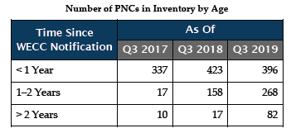
2019 December Board Meeting Material
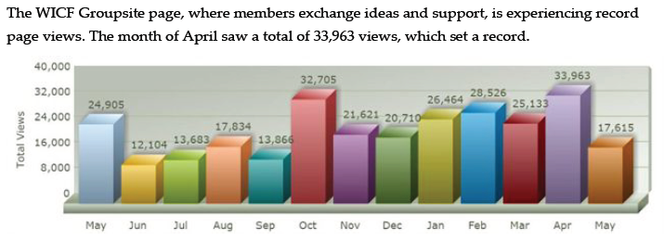
2019 June Board Meeting material

Sources
WECC 2020 Business Plan and Budget
WECC 2019 December Board Meeting Material
WECC 2019 September Board Meeting Material
WECC 2019 June Board Meeting Material

Appendix D—Committee Analysis
The following graphics show trends among the technical committee (i.e., those reporting to the Market Interface Committee (MIC), Operating Committee (OC), and RAC.)

Current Technical Committees
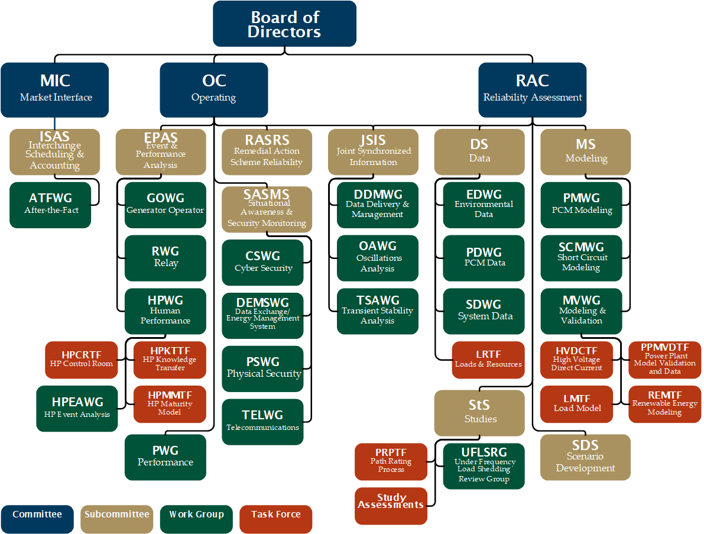

Average Attendance over 60% of Membership
The groups with a color-filled background are the groups whose meetings have had a two-year average attendance (members and others) that is over 60% of the number of committee members. The percentage was chosen only to represent a clear majority.
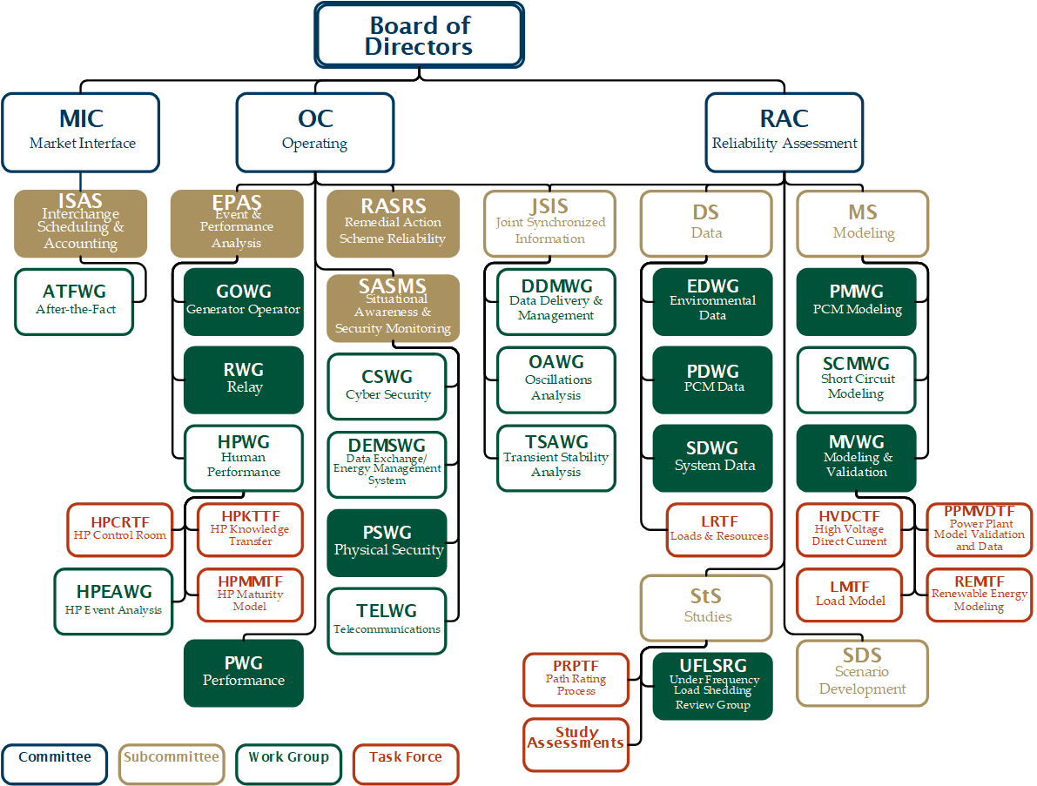

Addressing Near-Term Priorities
The groups with a color-filled background have an assignment to address the Near-Term Priorities in the Standing Committee three-year work plans. Other groups also have assignments in the three-year work plans that are not directly related to a Near-Term Priority.
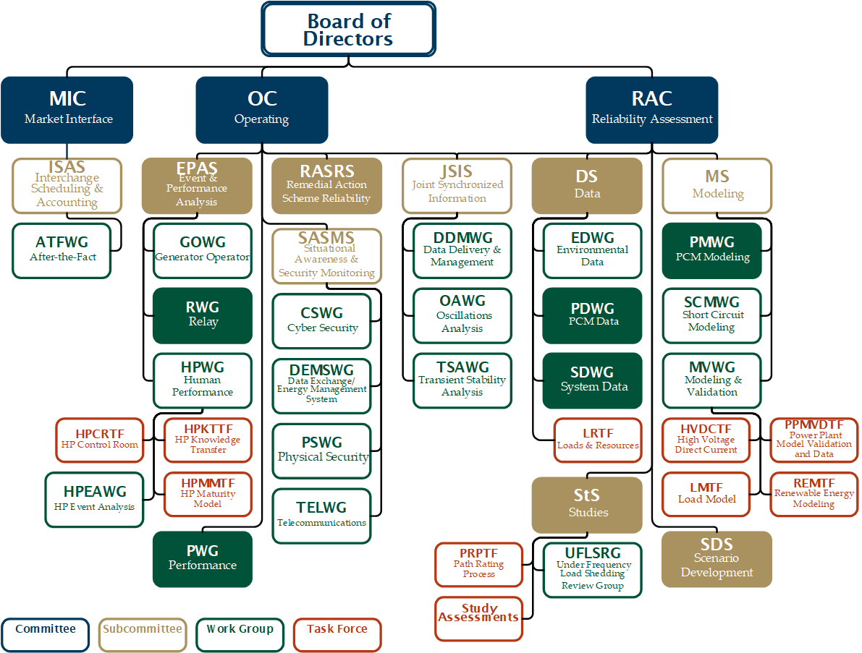

Unique Work Products
The groups with a color-filled background have unique work products. Those not highlighted:
- Share best practices on a common topic;
- Support the work products of other committees;
- Oversee subgroup activities; or
- Provide expert review for work done by WECC staff.
Those groups lightly filled are responsible for guidelines based on their expertise that require periodic review.
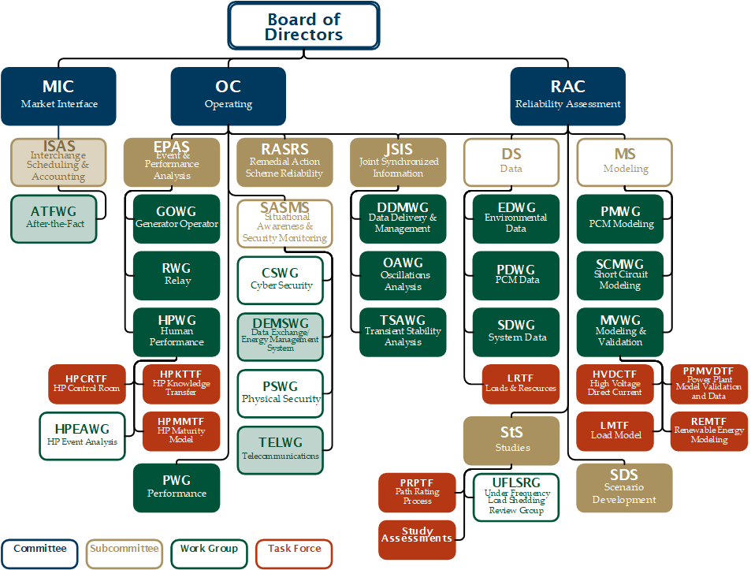

Recently Finalized Work Products
The groups with a color-filled background have completed a work product and received approval in the last two years. This does not include administrative items like leadership changes, charters, minutes, agendas, work plans, and protocols.
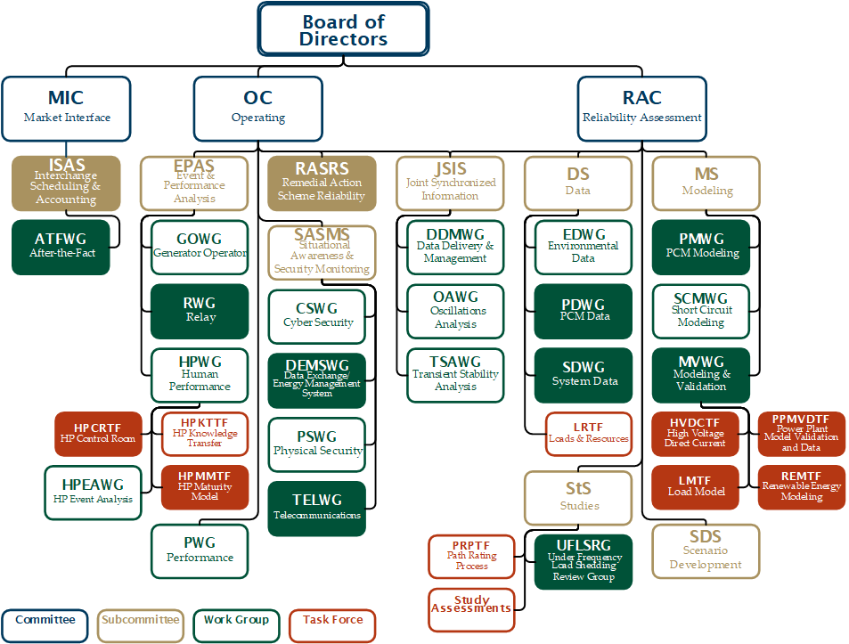

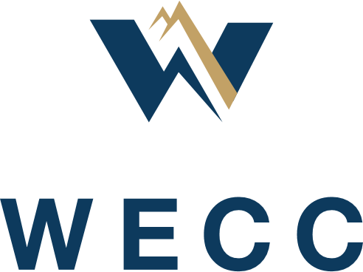

Strategic Planning Process Work Group (SPWG)

Final Recommendations
  - Jillian Lessner, SPWG Chair
  - April 6, 2020

Strategic Purpose
The Strategic Planning Process Work Group (SPWG) was created by the Section 4.9 Review Committee to review the strategic planning process at WECC. The electric industry continues to experience a rapidly changing environment. The level of variable generation in the resource mix and the increased use of digital control technologies present new risks to the reliability and security of the electric grid. Additional risks and threats will undoubtedly continue to emerge. Considering the changes in WECC’s operating environment, how should WECC address the following issues in its strategic planning process:
- How can WECC improve and streamline its strategic planning process?
- With the ERO Enterprise revising its long-term strategy, how will these changes impact WECC?
- How can WECC continue to align with the ERO Enterprise long-term strategy, while reflecting the uniqueness of the West?
- What are the long-term focus areas?
- How does WECC ensure member and stakeholder involvement in the strategic planning process?
- Is the bi-annual Western Reliability Summit a useful method to gather input for the strategic plan?
- How long should the strategic planning horizon be?

Background
WECC’s strategic planning process has been evolving since the last Section 4.9 review. In the 2015 Section 4.9 Report, one recommendation proposed a strategic, three-year operating planning process to encourage strong working partnerships between the Standing Committees and the Member Advisory Committee (MAC). In 2016, the Board of Directors (Board) developed a Strategic Direction Outline, which included five strategic focus areas. Also, in 2016, a 2017-2020 Operating Plan was developed. In 2017, the ERO Enterprise Framework was finalized, the WECC Strategic and Operating Planning Process was developed, and the 2018-2020 Operating Plan was revised to align with the ERO Enterprise Operating Plan. In 2019, NERC and the Regional Entities partnered to create an ERO Enterprise Long-Term Strategy, eliminating the three-year operating plan.

Work Group Approach
To inform its work, the SPWG discussed the Board-approved issue statements and the scope of the work as guided by the Board’s “desired outcomes” for WECC’s strategic planning process, outlined below. Ultimately, the group focused on what would be the best process for WECC instead of just taking what exists and “tweaking it” to make incremental improvements.

Board-approved Issues Statement—Desired Outcomes
- The process provides a clear linkage to our desired vision of the future and the high-level actions that are required to get there.
- The framework is streamlined and simple to understand, creating a plan that has enough detail to envision the possibility without being too prescriptive or resistant to new possibility.
- The plan created by this process is broad in scope, encompassing in its opportunity, and focuses more on the “why, what, and who” rather than on the “how.”
- Stakeholders are satisfied because they understand their opportunities to engage, are plugged in at the right time, and can see value for themselves in it.
The SPWG then discussed and analyzed:
- The current strategic planning process;
- The Near-Term Priority development process;
- What parts of each process are working or not working and why; and
- Alternative solutions that would be better suited for the Board-approved issue statement and desired outcomes.

Graphic Representation
The Business Plan Model (Figure 1) is the current graphic representation of WECC’s Strategic Direction Outline and the Near-Term Priorities development framework. It was originally developed as a model and, when viewed as such, it works. However, many stakeholders see it as a process. Over the past few years, many details have been added to the graphic in response to stakeholder feedback. The addition of all the inputs and opportunities makes the diagram busy and confusing for some. The complexity coupled with the non-linear format and merger of two processes may detract from important elements of the model. Some details, like the Delegation Agreement, are inherent or implied—we must operate within the bounds of our Delegation Agreement—so they need not be represented.
Figure 1: Business Plan Model
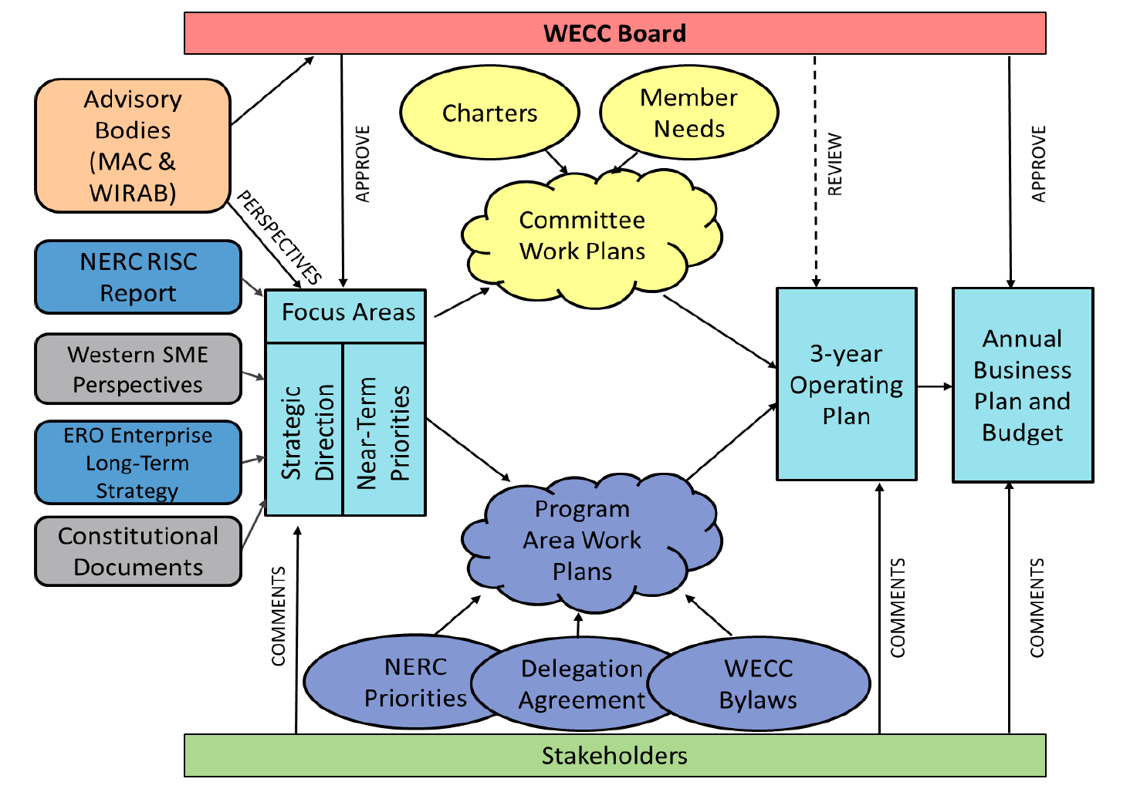

Recommendation
Figure 2 below is the SPWG’s recommendation for a graphic representation of WECC’s overall strategy. WECC’s vision and mission should shape the organization’s long-term strategy and reliability risk priorities. This linear representation is simple and flexible. The SPWG believes that a linear representation of the processes would be more easily understood, and therefore, useful to our stakeholders. The diagram is high-level and easy to grasp. The more details that are presented, the less flexible the visual becomes. Since many details incorporated into the Business Plan Model diagram have been eliminated, a companion document should be drafted that outlines the specifics of both processes. The SPWG believes this document will reduce some stakeholder confusion about the strategic process at WECC. The content will be covered in subsequent sections.
Figure 2: WECC Strategy
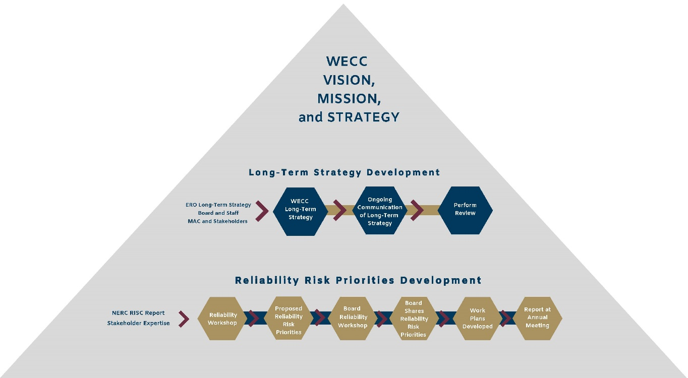

Strategy Terminology
The phrase, “Strategic Planning Process,” may also be causing confusion among WECC’s stakeholders, since the processes to determine the Near-Term Priorities and Strategic Direction Outline do not fit the traditional definition of strategic planning. The desired outcomes from this Section 4.9 review do not fit that definition either.

Recommendation
WECC should adopt more traditional and widely understood terminology: Long-Term Strategy should replace Strategic Direction Outline and Strategic Planning Process. A strategic plan has more specific objectives and timelines—a strategy has focus areas that help an organization move toward its vision. It is more fluid and allows more flexibility based on our organization and the environment in which we operate.

Long-Term Strategy Development
The SPWG discussed best practices for strategic planning in non-profit organizations and reviewed WECC’s Strategic Direction Outline development process. The Strategic Direction Outline is Board-approved and was developed through a collaborative process with the leadership of MAC and WIRAB and shaped through stakeholder input gathered during an open comment period and town hall meetings. It sets strategic priorities for WECC staff and stakeholder committees over multiple business-planning cycles. These priorities, combined with other ERO-delegated activities, guide the development of WECC’s operating and business plans in the coming years. Various technical stakeholder committees also align their work with these priorities. The strategy has a five- to seven-year horizon and review is scheduled to occur every five years or as conditions warrant.
This Strategic Direction Outline is working as intended for WECC; however, its development somewhat duplicates the recently approved ERO Enterprise Long-Term Strategy—WECC participated in its development and it is supported by the WECC Board. The terminology, however, is not working, as explained in the previous section. The SPWG members believe the non-standard terminology is unclear and undermines stakeholder engagement.

Recommendation
The SPWG recommends that WECC develop a long-term strategy with a five- to seven-year horizon, similar to the current state. The SPWG also recommends that the identification of long-term focus areas be left to WECC management and the Board. Management will draft the long-term strategy, with a mechanism for stakeholder input and feedback. The Board will approve it (June Board meeting). The ERO Enterprise Long-Term Strategy is an excellent starting point for WECC’s long-term strategy—it is representative of continent-wide risks, vetted through a stakeholder process, including several WECC stakeholders. This starting point demonstrates alignment with the ERO, and all Regional Entity Boards have approved or endorsed it in some fashion. Taking the ERO Enterprise Long-Term Strategy into consideration at the onset also minimizes duplication of efforts. Management will determine how to use that document to help shape the development of a long-term strategy that is appropriate for WECC and its operating environment in the West. The strategy will be reviewed informally every other year (in even years) during the May Board Reliability Workshop to ensure it is still meeting WECC’s and its stakeholders’ needs. Adjustments will be made, as necessary, to keep the Long-Term Strategy relevant. Every five to seven years, WECC will formally review and update the Long-Term Strategy to address changes in WECC’s environment.
There seems to be a consistent theme with stakeholders about what WECC’s long-term strategy is and how it relates to the work that WECC performs. The SPWG believes that a formal communications and outreach plan should be developed to ensure that WECC’s long-term strategy is communicated to both internal and external audiences and that the right message is communicated to the right audiences at the right time using the appropriate format. WECC’s mission, vision, and risk priorities should be linked to the long-term strategy. A small group of WECC stakeholders participates in the process currently, so a formal communications and outreach plan will be designed to reach a much broader and larger group of individuals and organizations.
To increase engagement and understanding, two-way communication linked to the long-term strategy should be developed. The SPWG suggests an interactive forum at the Annual Meeting in September would be an optimal way to increase stakeholder engagement in and understanding of WECC’s long-term strategy. This may also increase attendance at and participation in the Annual Meeting. Historically, communication of WECC’s Strategic Direction Outline, after initial development, has been one-way, which is information dissemination, rather than participative communication. While periodic information distribution is important, continual and interactive communication will help reduce confusion among WECC’s stakeholders and employees as well as increase engagement.

Risk Priority Terminology
The term “Near-Term Priorities” may be causing confusion amongst WECC’s stakeholders since near-term implies tactical, shorter-term priorities, rather than longer-term strategic priorities for the focus of the work.

Recommendation
WECC should adopt a phrase with a more strategic tone for risk-related strategic priorities. The SPWG recommends the term “WECC Reliability Risk Priorities.” Reliability should be in the name to emphasize the focus on reliability risks and WECC should be in the name to eliminate confusion with the risk priorities identified in the NERC Reliability Issues Steering Committee (RISC) Report.

WECC Reliability Risk Priorities Development
The SPWG reviewed and discussed the current process for the development of Near-Term Priorities. The Near-Term Priorities are Board-approved and are developed through a participative process with subject matter experts (SME), the MAC, and WIRAB. The process begins with the issuance of NERC’s RISC report in the fourth quarter of odd-numbered years. Those reliability risks are reviewed at the Reliability Workshop in the first quarter of even years. The Reliability Workshop provides an opportunity for the MAC, WIRAB, and technical committees to review the RISC Report in a western context and provide input on any other western-specific reliability issues. Staff then summarizes the content from the workshop for the Board to use as input at its Board Workshop in May. Following the Board Workshop, a final summary of recommended Near-Term Priorities is prepared for approval at the June Board meeting. There are opportunities for stakeholder comment between the Reliability Workshop and Board-approval of the Near-Term Priorities in June.
Once approved, the Near-Term Priorities help shape the work undertaken by staff and committees in the three-year operating and work plans, which are updated annually and cover a rolling, three-year period. Another input to the process is the Western Reliability Summit, which is held every other May in even years. It was structured to provide an opportunity for senior leaders across the industry to share thoughts and participate in discussions that will help shape and influence the direction of and priorities for WECC’s work and products over the coming years.
In general, the current process is working and produces a quality list of risk priorities facing the Western Interconnection that WECC addresses in its work and products. However, there are parts of the process that are redundant and ineffective. The SPWG thinks the most effective result for the development of reliability risk priorities involves restructuring the process and eliminating some parts.

Recommendation
The WECC Reliability Risk Priorities (WRRP) development process is more involved than the strategy development process, so recommendations are presented by process component.

Communications and Outreach
Like the strategy development process, there seems to be a consistent theme with stakeholders, in general, about the Near-Term Priorities development process and how WECC’s work relates to the Near-Term Priorities. The SPWG believes that a formal communications and outreach plan should be developed to ensure the right message is communicated to the right audiences at the right time using the appropriate format—this includes internal and external audiences. All WECC work and products should be linked to the WRRPs, mission, vision, and strategy. A small group of WECC stakeholders participates in the process, so a formal communications and outreach plan would reach a much broader and larger group of individuals and organizations and increase awareness, participation, and engagement. Communications and outreach should be focused on every stage and product of the WECC Risk Priorities development process.

NERC RISC Report
This is a thorough report providing key insights and priorities for issues related to the reliability of the bulk power system. This is a valuable input to the development of WECC’s risk priorities. A western view may be overshadowed by eastern or other views, so unique, western-reliability-focused issues may not be adequately represented. WECC should continue to use this report as an input and ask for reviews of and input on the report from western SMEs.

Reliability Workshop
The biannual Reliability Workshop is a valuable starting point for the risk priority development process. The two workshops (2018 and 2020) have been well attended and stakeholders were engaged. Both workshops produced comprehensive lists of common western reliability risks based on the expertise of SMEs. Continual improvement of event formatting should be a focus to improve attendance, participation, and engagement. Also, communications and outreach are vital to attracting and engaging SMEs with the expertise to evaluate reliability risks. Historically, this has been a RAPA event—there may be Compliance Monitoring and Enforcement Program SMEs who have a different kind of expertise that would be just as valuable, and WECC should broaden the target audience for the workshop. The SPWG would also like the MAC to increase member attendance, facilitation, and participation in the event as representatives of their classes.
WECC staff develops a paper informed by stakeholder input at the workshop, which is key to identifying reliability risks. The paper is also a well-vetted input to the Board Workshop. The SPWG recommends that staff ensures the risk priorities are aligned with WECC’s mission, vision, and long-term strategy in the paper.

Board Workshop
To tie all the strategy-related events together, the SPWG recommends changing the name of the Board Workshop to Board Reliability Workshop.
This workshop works well to identify risks to reliability in the Western Interconnection. The SPWG believes this is also the right time and place to perform a biannual review of the long-term strategy to ensure that it is still appropriate and valid. Based on the operating environment, the Board should update WECC’s long-term strategy if warranted.
This workshop is also the perfect time to ensure that WECC’s vision, mission, long-term strategy, and reliability risk priorities are all aligned. This is a critical oversight role of the Board.
There are no recommended changes to the output of the Board Reliability workshop other than increasing communications and outreach and confirming the alignment of WECC’s mission, vision, long-term strategy, and risk priorities. WECC staff develops a paper informed by the discussions at the Board Workshop. The process to develop the paper of recommended risk priorities for June Board approval, and to solicit feedback from stakeholders, is currently working well.

Three-Year Operating Plan
WECC’s three-year operating plan is based on the ERO Enterprise Operating Plan, which was eliminated in 2019. Some duplication exists between the operating plan and the work plans, and the operating plan is rarely referenced. There are many documents and products associated with WECC’s overall strategy, which may create confusion with stakeholders. Therefore, the SPWG recommends eliminating the three-year operating plan.
To ensure no valuable content is lost, three-year work plans and the annual Business Plan and Budget should be bolstered and expanded if the operating plan is eliminated.

Western Reliability Summit
The Western Reliability Summit does not seem to be functioning as intended. It is not attracting senior-level executives, other than on the panels, and there is limited engagement and participation aside from the audience. It has captured the interest of stakeholders, but the format seems to be more appropriate for information dissemination than gathering input to develop risk priorities. The timing is also off for the risk priority development process—the summit is held in May of odd years, and reliability risk priorities are vetted beginning in the first quarter of even years. For these reasons, the SPWG recommends eliminating the Western Reliability Summit.
The SPWG also recommends using the technical session at the Annual Meeting to discuss the WECC Reliability Risk Priorities and Long-Term Strategy. The session should be interactive to increase engagement and awareness and demonstrate to stakeholders how their participation shaped the results.

Committee and Staff Work Plans
Committee and staff work plans should be bolstered to ensure that no critical information is lost due to the elimination of the Three-Year Operating Plan. Additionally, WECC should increase efforts to highlight and communicate insights gained from its work and products that may be valuable to people outside of the technical committees. The Joint Guidance Committee (JGC) works to coordinate the efforts of the technical committees and their work plans. There are no recommended changes to the JGC’s work.

Business Plan and Budget
The Business Plan and Budget should be bolstered to ensure that no critical information is lost due to the elimination of the Three-Year Operating Plan.

Next Steps
This report is the final product of the SPWG. The work group will take on any further action items assigned by the Section 4.9 Review Committee and the Board of Directors. The work group believes that responsibility for the following major recommendations rests with WECC management:
- Develop WECC’s Long-Term Strategy;
- Develop a Communications and Outreach plan for the Long-Term Strategy and WECC’s Reliability Risk Priorities;
- Work with MAC leadership to increase MAC engagement in the Reliability Workshop; and
- Review the development processes for work plans and the Business Plan and Budget to ensure no critical information is lost due to the elimination of the Three-Year Operating Plan.

Stakeholder Engagement Model Issue Statement, approved by the WECC Board of Directors, December 4, 2019.
RAC Charter
WICF membership is limited to employees and contractors of WECC Registered Entities involved in compliance. WICF has 1,455 members in Groupsite.
Strategic Planning Process Issue Statement, approved by WECC’s Board of Directors, December 4, 2019
Ibid.
Ibid.

