# Resource Data

The Anchor Data Set (ADS) uses loads and resources provided through the annual Loads and Resources (L&R) data submittal process. The L&R submittals include forecasts of expected monthly peak loads and expected monthly energy loads for each of the 10 years into the future from the submittal year.

Building the PCM dataset starts with reading in network topology and resources from the year-10 power flow case. The power flow case may not completely match the resources submitted through the L&R process. Reconciling differences leads to identifying resource differences, generally planned resources for which definitive locations are not yet known. This document goes through the order of operations that will be utilized to place resources that are included in the L&R submittal but are not included in the power-flow model.

## Resource Placement

This section defines the order preference of placing resources from the loads and resources process.

1. Use the resource location (bus number) provided in the year 10 power flow base case developed through the System Review Subcommittee (SRS) process.
2. If the resource location is not available, contact the transmission planner and resource planner to receive location (bus number or Longitude and Latitude) along with any other pertinent information.
3. If the resource location is not available through the transmission/resource planner, review the resource mapping work from the previous Anchor Data Set and use that bus number from the previous ADS if it exists. Notify the pertinent transmission planner on the bus number(s) thus assigned. If the earlier Anchor Data Set bus number is used perform the checks outlined below to ensure the location is still appropriate.
4. If none of the previous information is available, place resources considering the following:
   * Do not exceed the transmission capacity of point of interconnection
   * Rules of thumb for amount of capacity to add at various voltage levels

| Interconnection Voltage | Resource Capacity |
| --- | --- |
| 0 to 34.5 kv | Up to 5 MW |
| 34.5 to 69 kv | 5 to 25 MW |
| 115 kv | 25 to 50 MW |
| 230 kv | 50 to 125 MW |
| 500 kv | 250 to 1250 MW |

* + If available, use latitude and longitude to place on the closest high voltage bus consistent with the previous item.
  + If available, find the county where the resource is located in the Loads and Resources submittal or from Energy Information Administrator (EIA) 860 and place the resource on a high voltage bus inside or near that county
    - Aggregate small (< 10 MW) resources by county, modeled as an aggregate generator. See workflow figure 1 for work flow.

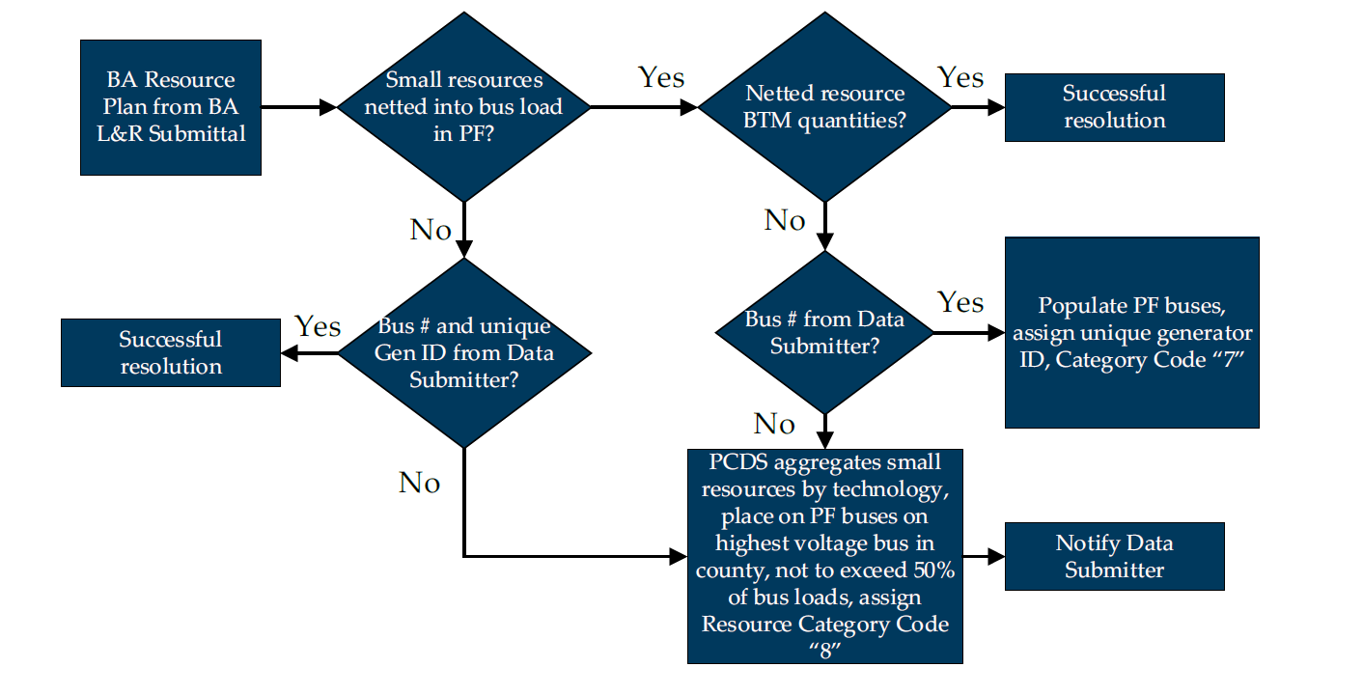

Figure 1: Modeling in front of the meter small resources that have not been explicitly modeled in the PF[1]

* + If no information about reactive capability is available, assume ±33% of capacity based on the draft IEEE P2800 Standard for IBR. Reactive capability of other types of resources will be handled case-by-case.
  + As resources are being placed in the power flow, perform these steps:
    - Add generators to ADS reference power flow case
    - Test for any steady state overloads and voltage outside of typical ranges (generally .85 – 1.15 pu)
    - Fix issues and notify the TP and Resource Planner of the issue and the solution used. Options are:
      * Redistribute resources to different buses if found to cause issues
      * Adjust reactive capacity from ±33% as needed to fix issues
      * Move to a higher voltage bus

## Considerations

Issues that have been seen in the past should be handled as follows.

* Future generic units larger than 1250 MW from the Loads and Resources submittal should be broken into multiple smaller units of (100 mw or less) to avoid overloading the transmission system
* If no unit type is provided, solar or wind will be assumed depending on location.
* Resource retirements in the L&R – remove any resources that are marked for retirement in the L&R that have remained in the starting power flow case (heavy summer base case)
* Resource data from Balancing Authorities via the L&R needs to be available by December 31 of the year the power flow case is created. If data is not available resources from the previous year’s L&R submittal, will be used and placed according to this guidance.

1. Figure from the “Proposed Reconciliation of LR Data.pdf”