*The following is an example change request to function as a template for actual requests. Please complete the template with as much detail as possible. The SDWG Chair, Vice Chair, and the Compliance Coordinator can be contacted for assistance.*

*A SDWG member should submit the completed request by posting the document on the SDWG Team Site available at this* [*link*](https://www.wecc.org/teams/SRWG/Shared%20Documents/Forms/AllItems.aspx?RootFolder=/teams/SRWG/Shared%20Documents/Data%20Preparation%20Manual%20Working%20Files/DPM%20Change%20Requests&FolderCTID=0x012000C83CB1C191399147ABDE3B51B4527C47&View=%7bFD371B64-DAA9-4575-A2E3-3372F6FA7DB3%7d).

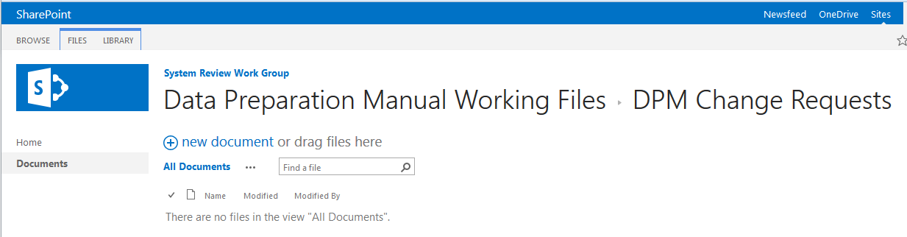

Post change request here

# Change Summary

Change the branches, connectors, and transformer last four order of seasons in base cases.

# Schedule

Incorporate language into DPM: For inclusion in 2023 DPM.

Start using the proposed order of seasons with the 2023 Base Case Compilation Schedule. Which typically begins in the fall of each year.

# Detailed Description

Change Ratings 5, 6, 7 and 8 to Spring Normal, Spring Emergency, Fall Normal and Fall Emergency from Fall Normal, Fall Emergency, Spring Normal and Spring Emergency.

## Benefits

Seems like a more logical order.

## Cost

The following “costs” may be incurred by completing the proposed DPM change request:

* Data Submitters will populate last four season ratings as proposed.
* Data Submitters will continue to populate first four seasons as they do currently.

## Alternatives

No alternatives from the proposed change exist, other than not changing.

# Proposed Edits

Proposing to change the order of the last four season ratings in base cases.

From

Rating 5 Fall Normal

Rating 6 Fall Emergency

Rating 7 Spring Normal

Rating 8 Spring Emergency

To

Rating 5 Spring Normal

Rating 6 Spring Emergency

Rating 7 Fall Normal

Rating 8 Fall Emergency

# Examples