Project Management
Developing the 2034 Anchor Data Set (ADS) on time will require sound project management with clearly defined roles and responsibilities. WECC proposes the following project management approach:
Role | Person Responsible | Primary Responsibilities
PCDS ADS co-chairs | PCDS co-chairs | - Provide focus on administrative tasks  Support WECC staff through the development of a project plan  - Schedule data development discussions and decisions through PCDS  - Moderate PCDS discussions  - Provide technical leadership for building the ADS  - Ensure appropriate stakeholder involvement for each pertinent technical item  - Data development with National Labs/DOE and other vendors
2034 ADS Project Manager | WECC-assigned PM | - Report regularly on ADS schedule  - Document and follow up on identified issues
PCDS | Data assumptions and development plan | - Discuss and approve data assumptions and the plan for database development. Identify new input parameters, new modeling approaches, and roadmap of implementation including allocating works to SME or consultants as time and resources allow
SME—internal | WECC SAP and SSP department staff members | - Develop input data for ADS  - Input data to GridView to build the ADS  - Review modeling runs and report on results  - Document data development processes
SME—external | PCDS members; other stakeholders | - Review technical issues brought to the PCDS for consideration and decision  - Work with WECC and stakeholders to develop ADS input data  - Document the ADS data development processes  - Test and validate ADS

Timing Constraints
Based on discussions with the regional planning groups, this is the timeline for developing their regional plans. It begins in January of the even year.
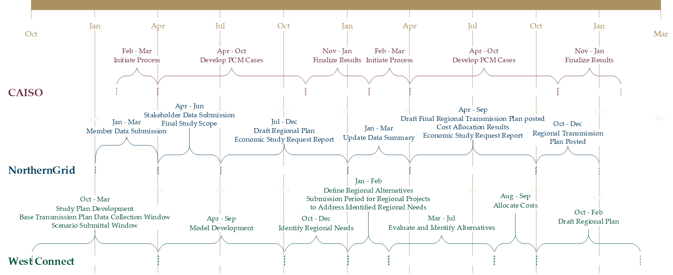
Figure 1: Regional planning group timelines

Loads and Resources Data
The Loads and Resources (L&R) data is the basis for the load and resource forecast in the ADS build process. In the past, the data collected in the even year, the same year as the ADS build, was used to build the ADS.

Concerns with the Current Process
The ADS is a major input into the regions’ planning processes by providing resource placement for resources outside of their respective footprints. The regional planning processes have been a key driver for the initial release of the ADS by June 30 of the even year.
Due to the complexity of building the ADS, additional time and resources may be needed to meet the June 30 release date. WestConnect’s timing needs are even more demanding, since it begins building its dataset in Q2 of the even year (Figure 1); currently, it must start with the previous dataset.

Proposed Solution
In the 2032 ADS Lessons Learned meeting which occurred in October 2022, WECC staff asked the regions whether using the previous (odd) year’s L&R data could be a solution for completing a dataset by June 30 of the even year. The regions were open to this solution with the possibility of updating the resources with the even year’s L&R data once the ADS is complete.
This timeline proposes building the 2034 ADS beginning in July 2023, with the initial ADS release on March 29, 2024, followed by subsequent releases.

2034 ADS Initial Release (V1.0) Timeline (2023 L&R data)
- February 1–July 1, 2023: PCDS determines which other data needs to be updated for 2034 ADS PCM
  - February 1–June 30, 2023: PCDS determines schedule for reviewing data
  - June 1, 2023: Stand-up Anchor Power Flow Task Force (APFTF)
  - July 1, 2023: Finalize which other data will be updated for 2034 ADS PCM
  - February 1–July 1, 2023: PCDS creates and approves enhanced data checks to be used for validation
- July 1–December 31, 2023: Create, collect, and implement other data (PCDS and WECC, consultant and national labs)
  - Including updates for hourly profiles, hydro data, heat rate data, etc. if needs are identified by PCDS
  - Also including possible modeling and software enhancements
  - This step should have higher priority than the v1.0 ADS PCM case if they compete for time and resources
- July 1, 2023–January 15, 2024: Use L&R resource data received in 2023 to build 2034 ADS.
  - July 1, 2023: Compare 2023 L&R resources to 2022 L&R resources. Begin mapping the L&R resources to the 2034 Heavy Summer 1 (34HS1) power flow (PF) pre-run case
  - September 1, 2023: Verify mapping using the finalized 34HS1 PF
  - September 15, 2023–October 10, 2023: APFTF complete mapping and place planned resources

  - October 10, 2023–October 31, 2024: Pacific Northwest National Laboratory (PNNL) add L&R planned resources to 34HS1 PF to create 2034 Reference PF and solve 2034 Reference PF with only L&R resources and validation of solved PF
  - October 31, 2023: All resources added to 2034 Reference PF (WECC)
  - November 1, 2023–December 1, 2024: Import reference PF into PCM, add all resource data into PCM (WECC and consultant)
  - December 1, 2023–January 15, 2024: Validate 2034 ADS PCM v1.0
    - December 1, 2023–December 31, 2023: Verify resource placement and definitions in PCM and PF (PCDS and consultant)
    - January 1–January 15, 2024: Validate inputs using enhanced data checks to the ADS PCM (PCDS and consultant)
- January 15, 2024: Release 2034 ADS PCM and PF V1.0

2034 ADS Subsequent Release (V2.0) Timeline
- Add consultant work as needed
- February 1–April 15, 2024:
  - By March 15, 2024: Validate 2024 L&R data,
  - By April 15: Update 2034 ADS loads using the validated 2024 L&R data
- February 1–April 30, 2024: Map and add incremental L&R resources to the 2034 Reference PF
  - By March 15, 2024: Validate the resources in the 2034 L&R
  - March 15, 2024–March 31, 2024: APFTF complete mapping and place planned resources
  - April 1, 2024–April 15, 2024: PNNL add L&R planned resources to 34HS1 PF to create 2034 Reference PF and solve 2034 Reference PF (all resources in)
- May 1–May 31, 2024: Import reference PF into PCM, add all resource data (as necessary) into PCM (WECC and consultant)
- February 1–May 31, 2024 PCDS and WECC staff to update all other data required for ADS PCM and add to ADS PCM (this is continued work that started in 2023; may need support from consultants and national labs)
- June 1–June 30, 2024: Validate 2034 ADS PCM V2.0 (PCDS and consultant)
- June 30, 2024: Release 2034 ADS PCM and PF V2.0

