Enrolling in Multi-factor Authentication (MFA)
As a WECC.org user, you may be granted access to certain secure portions of WECC.org that contain confidential information or restricted collaborative community sites. Accessing these portions of WECC.org requires another authentication factor in addition to a username and password.

Choosing A Second Factor for MFA
Once the WECC administrative services team has assigned your WECC.org user account to the correct access group, login to WECC.org using your previous username and password. You will then see three potential options for your second factor: Google Authenticator (this is a generic, time-based one-time password (TOTP) and should work with any TOTP application, not just Google Authenticator), the Okta Verify app, and ‘Security Key or Biometric Authenticator’ (FIDO2/WebAuthn/Passkeys).
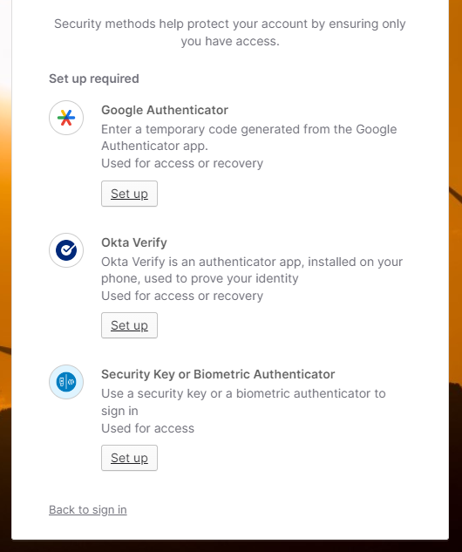

Google Authenticator
As a second factor, the Google Authenticator option is best used on your mobile device with a camera. However, it also works with desktop browser extensions, like those from Bitwarden and 1Password for Chrome, Firefox, and Edge, without the need for a mobile device. Google Authenticator will work with almost any multi-factor authentication application, not just Google Authenticator, including Microsoft Authenticator, Authy, Bitwarden, Apple ID iCloud Keychain, and others. To enroll:

OPTION 1 – Mobile Device
- Click Set up under Google Authenticator.
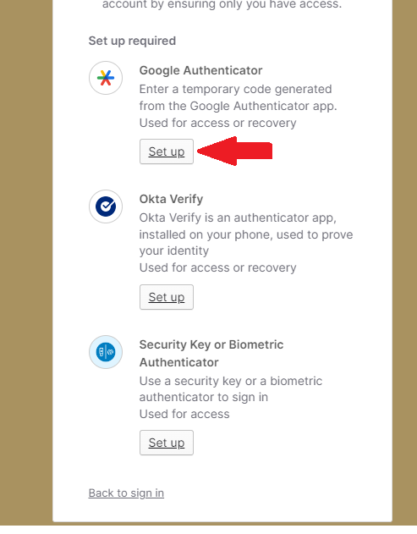
- Scan the QR code with the MFA mobile app of your choice. Then click Next.
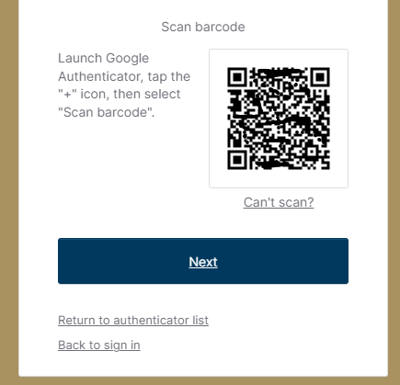
- Enter the six-digit code assigned to the account in the MFA app (changes every 30 seconds) and click Verify.
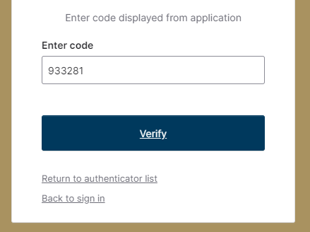

- You will see an option to enroll additional factors. Since you have already enrolled in a second factor, skip this step and click Continue.
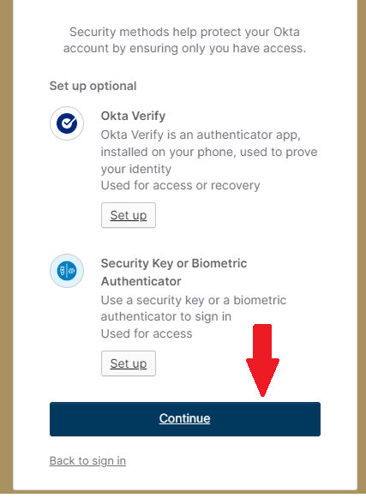
- You will now have access to WECC.org with elevated permissions and access.

OPTION 2—Browser
As an alternative to using a mobile device, such as a phone or tablet, many popular password managers offer browser extensions for Chrome, Firefox, and Edge, that can provide QR code-based codes like their mobile app counterparts. Popular options include Bitwarden, 1Password, and Apple ID iCloud Keychain. The following is an example of how to use the Google Authenticator option without a mobile device, using only the Bitwarden Chrome extension (paid subscription required). The process will be similar in most other browser extensions:
- Install the Bitwarden Chrome extension, (NOTE: this functionality requires an active, paid subscription to Bitwarden).
- Log into your existing Bitwarden account, or sign up for a new account. The Bitwarden extension icon will be blue and white when it is active and ready to enroll MFA QR codes:
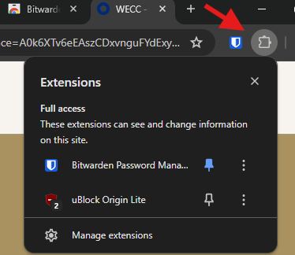

- Log into WECC.org using your username and password.
- Click Set up under Google Authenticator.

- Once you see the QR code, click Add a login to create a new entry in Bitwarden.

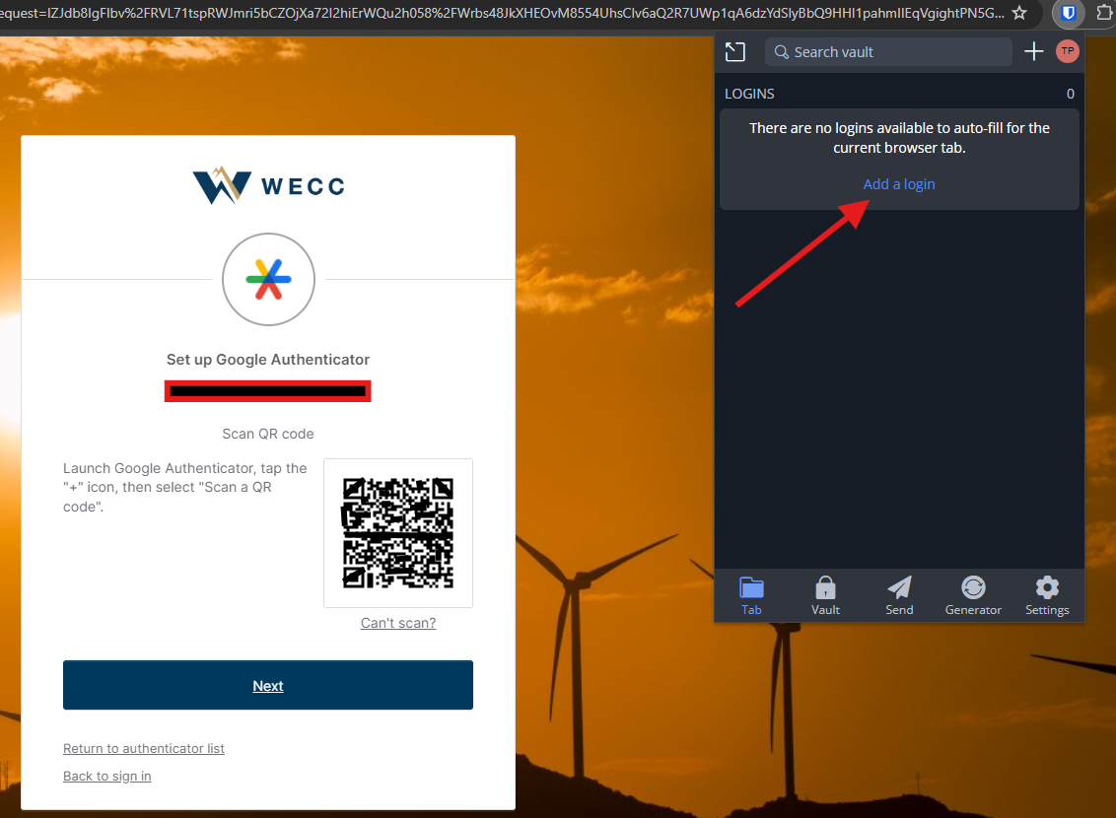
- Under “Authenticator key (TOTP),” click the camera icon, which will scan the current web page for QR codes.
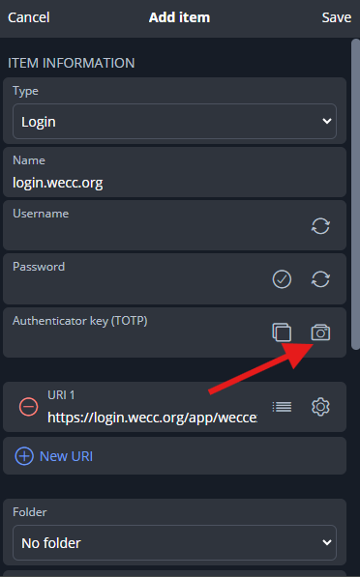

- Click Save. Select login.wecc.org in the logins list. Click Verification code (TOTP) and copy the code to the blank field in the web page. Click Verify.

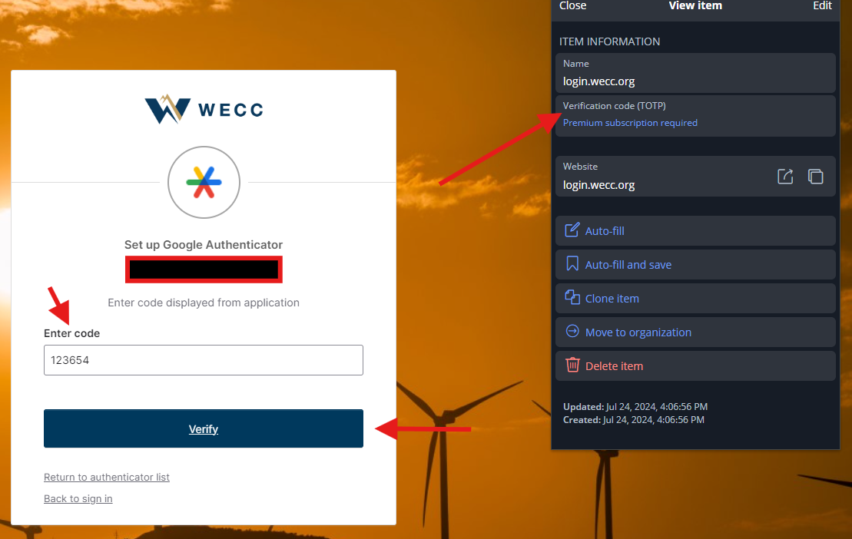

- You are now enrolled.

OPTION 3—KeePassXC, desktop software
KeePassXC is a powerful, advanced, and free password manager and MFA code generator available for Windows, MacOS, and Linux. In addition to managing passwords, you can use KeePassXC to generate MFA codes for WECC.org. To use KeePassXC for MFA in WECC.org, install KeePassXC. Create a new entry for login.wecc.org, then do the following:
- Right-click the selected entry for login.wecc.org and select TOTP, then Set up TOTP.
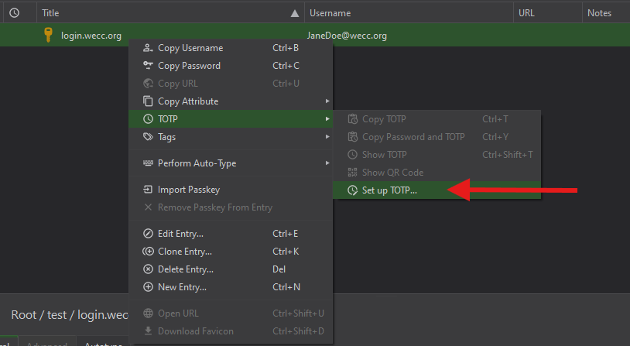
- Sign into WECC.org using your registered username and password. Click Set up under Google Authenticator.
- When you see the QR code, click Can’t Scan?
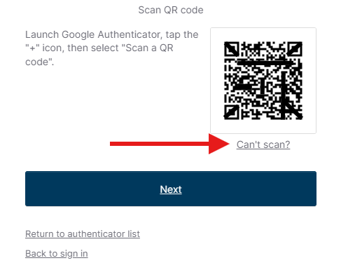
- Copy the code presented in the box. Click Next.
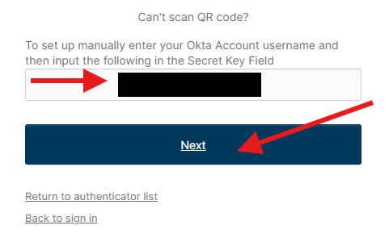
- In KeePassXC, copy the code from login.wecc.org into the Secret Key field. Click OK.
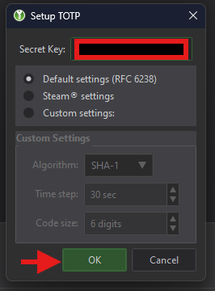

- Right-click the entry for login.wecc.org. Select TOTP, then Show TOTP.

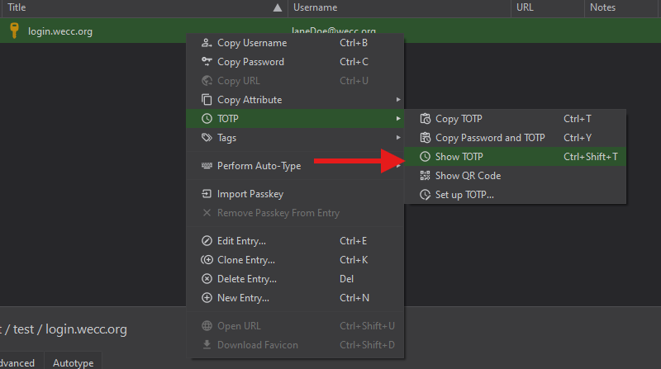

- You will see a six-digit TOTP MFA code generating every 30 seconds. Click Copy.
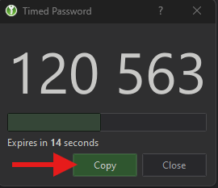

- Paste the code into the text box in login.wecc.org. Click Verify.

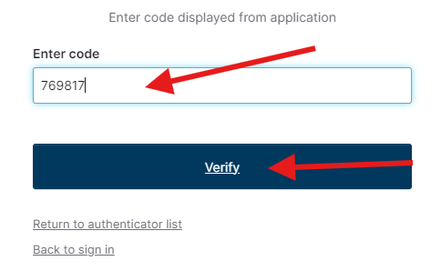
- You will see an option to enroll additional factors. Skip this step and click Continue.

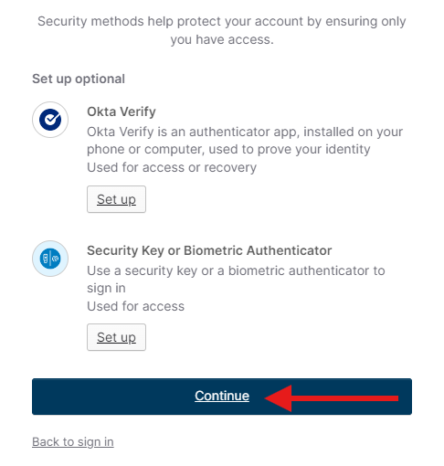

Okta Verify
Okta Verify is a multi-platform MFA application available for major operating systems including Android and iOS. The setup is similar to the first option, Google Authenticator. The difference is that Okta Verify can send mobile push notifications for verification, removing the need to enter rotating six-digit codes. To set up Okta Verify as your second factor:
- Download and install the Okta Verify application for iOS https://apps.apple.com/us/app/okta-verify/id490179405 or Android https://play.google.com/store/apps/details?id=com.okta.android.auth
- Click Set up under Okta Verify in the browser window where you have logged into WECC.org
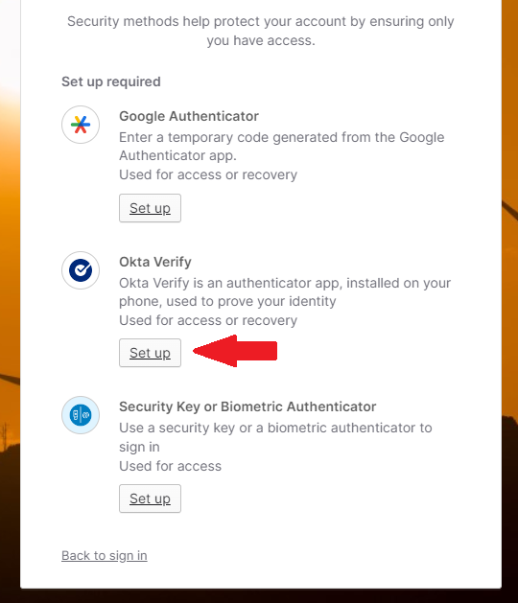
- Open the Okta Verify app on your mobile device, tap the ‘+’ button, then scan the QR code.
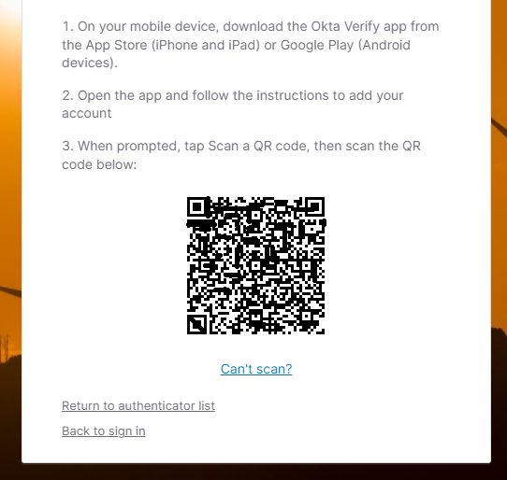

- Click Continue on the next screen to skip the enrollment of any additional factors. You will be redirected to WECC.org with elevated permissions and access.
- On your next logon, you will see an option to “Enter a code” through Okta Verify, or “Get a push notification” through Okta Verify. Click Select next to ‘Get a push notification’. On your mobile device, tap the push notification. Then tap Yes, it’s me.
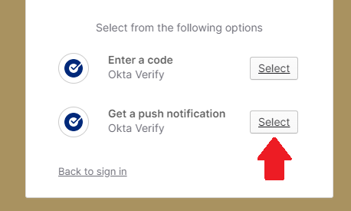
- You are done! You will be redirected to WECC.org.

Security Key or Biometric Authenticator
WECC.org supports FIDO2/WebAuthn/Passkeys through the option “Security Key or Biometric Authenticator.” This might be the best option if you are already using FIDO2/WebAuthn/Passkeys or use a security key such as the Yubikey or Google Titan Security Key. To make this method your second factor:
- Log into WECC.org, then click Set up under “Security Key or Biometric Authenticator.”

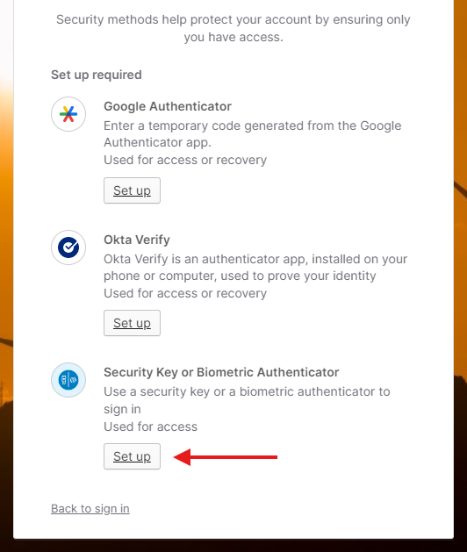
2) Click Set up on the next window.
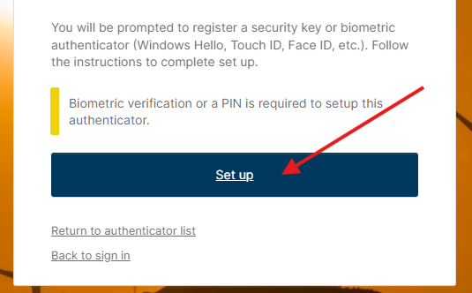

3) Click OK in the next window.

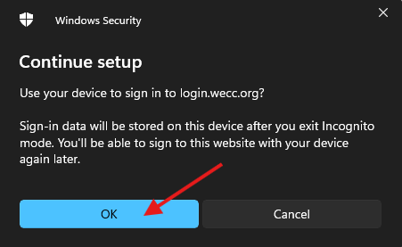

OPTION 1—iOS device or Android Device
If you would like to use this option with an iPhone, iPad, or Android device, follow the instructions below. If you would like to use a hardware security key such as the Yubikey or Titan Key, skip to option 2:
- Click iPhone, iPad, or Android device, then click Next.

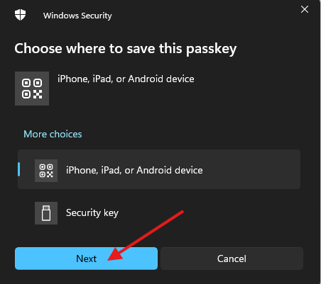

- Click Turn on Bluetooth (also ensure that Bluetooth is enabled on your mobile device)

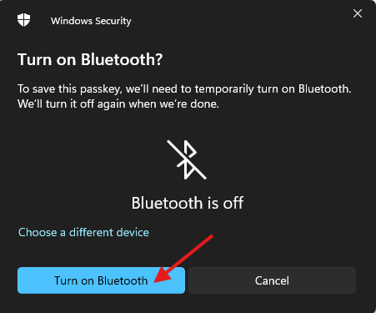
- Scan the displayed QR code with your mobile device’s passkeys-compatible MFA application.
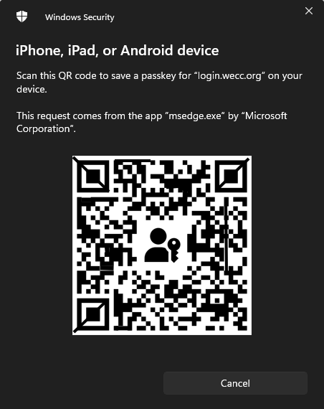
- Click OK to save the passkey to your mobile device.
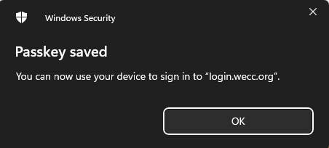

OPTION 2—Hardware Security Key
In lieu of an Android or iOS device, you can use a hardware security token such as a Yubikey or Google Titan Security Key. To get started using a hardware security key:
- Click Security key, then click Next.
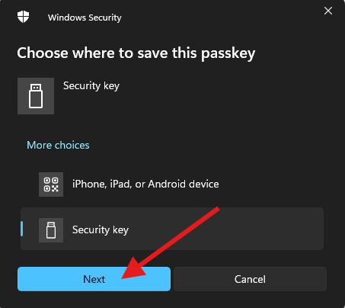

- Click OK to confirm security key setup.
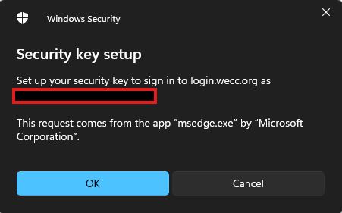
- Click OK to continue setup. Ensure that your security key is connected to your computer.

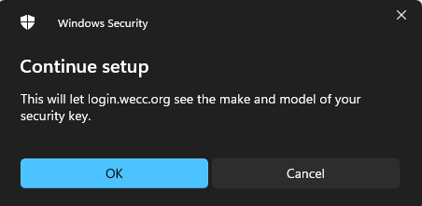

- Create a PIN, then confirm the PIN. Click OK.

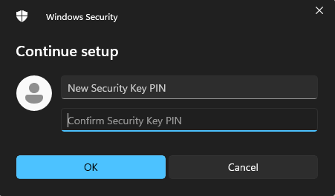

- Touch the hardware security connected to your computer.
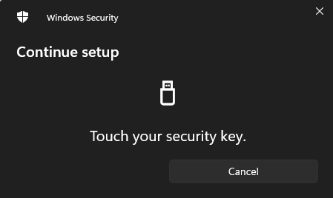
- Click OK to save the passkey to the hardware security token and complete the enrollment process.
